**Discuss the brief**

For this brief I will be working on game graphic assets for a game idea, I will also research and discuss the target audience and the legal and ethical considerations for the game and the ideas that I generate. The game that I have choose a game idea called Hotel sundown from a previous assignment, the premise of the game is that the player wakes up in the top floor room of Hotel Sundown which overnight has been overrun with mutant bugs, the goal is to reach the bottom floor safely and along the way the player can discover what happened, fight enemies and save other residents.

For this assignment I will initially create a mind map to broaden the ideas that I have for the game, this will help me with creating concept art and understanding target audience. Once done with the mind map I will move onto concept art creation where I will consider the ideas I have had for the game and draw various concepts for each idea. Finally I will talk about the legal and ethical considerations that surround the game idea and concept, also I will discuss the target audience and how other similar games have dealt with target audience.

The Software that I will use includes Photoshop, Gamemaker, Word and MindMup. Photoshop is very dynamic software and can be used for lots of different projects, Gamemaker is popular software for 2d games and I will be using it because I have a good amount of experience with it and there have been a lot of successful game made with it like Hotline Miami and Angry birds.

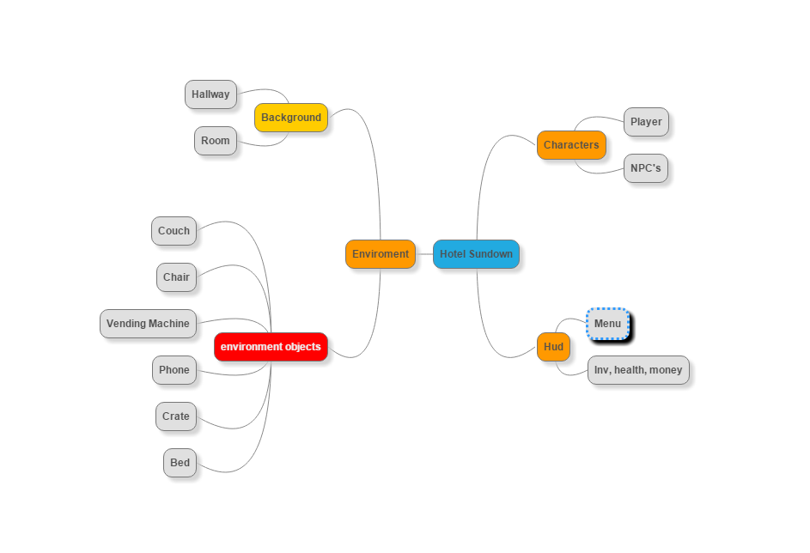

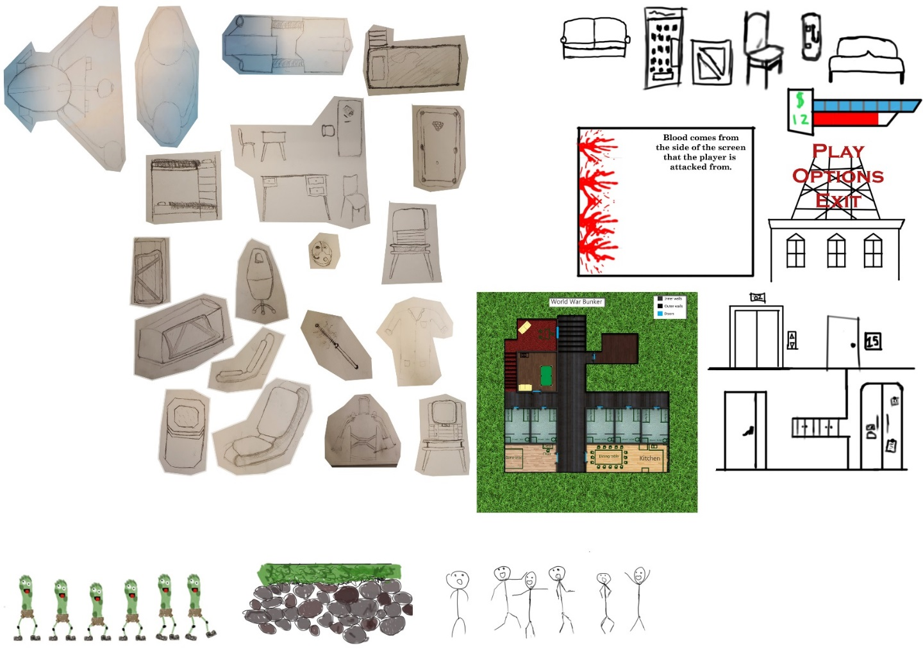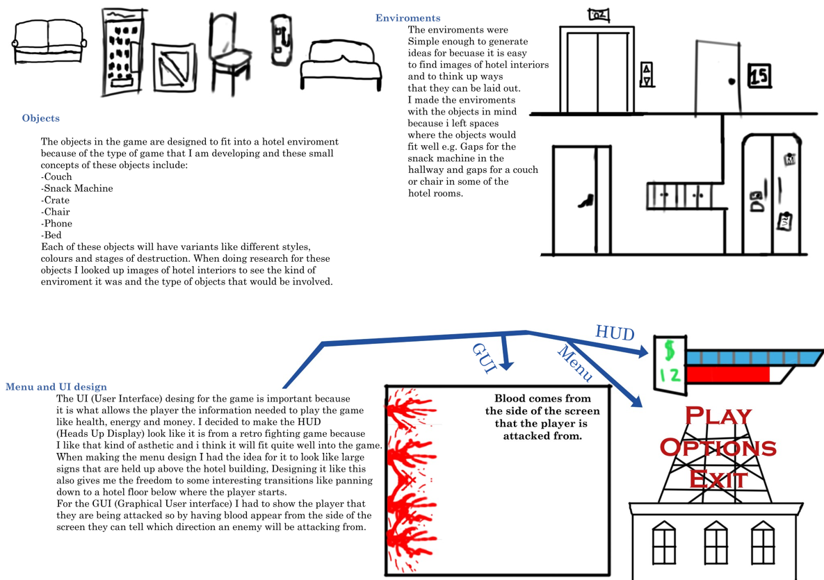

**Legal and ethical**

It is important for all games to consider the legal and ethical issues that may be faced, with Hotel Sundown the premise of the game includes killer bugs which means that violence will have to be considered. Similar games like Darkest Dungeon are a good thing to look at for research into what to consider about making a game with moderate violence and gore.

**Target audience**

Each game idea has a different target audience and that means that the legal and ethical issues come into consideration when it comes to deciding who to target the games at. Similar games to mine will be a good place to look to find out how popular the game will be, a similar game to mine is The Last Stand which is a zombie survival flash game which has had quite a lot of popularity and similar to my game it has a lot of replay ability.

The game has been hosted on a multitude of flash game sites but on just one of the most popular sites it has managed to gather over 10 million plays since 2007. The popularity of the game also helped spawn sequels like The Last stand 2 and The Last Stand 3 Union City which have increased the series in popularity.

**The Last Stand 2**



**The Last Stand 3 Union City**



I think that this kind of game has huge potential to become very popular again and span along sequels, unlike The Last Stand my game would be released on console platforms which would also help it be much more accesable.