|  |  |
| --- | --- |
|  | 3D Environment Evaluation |
|  |  |
| Mark Woods | | Outcome & Evaluation |
|  |  |

3D Environment Evaluation

**Contents**

**Contents**

**Environment Renders**

**Concepts Comparison**

**Technical & Aesthetic qualities**

**Workflow & Time management**

***Page 1 :***

***Page 2 :***

***Page 3 :***

***Page 4 :***

***Page 5 :***

Environment Renders

These Collective images show the Environment model in its complete from with all the individual 3D assets.

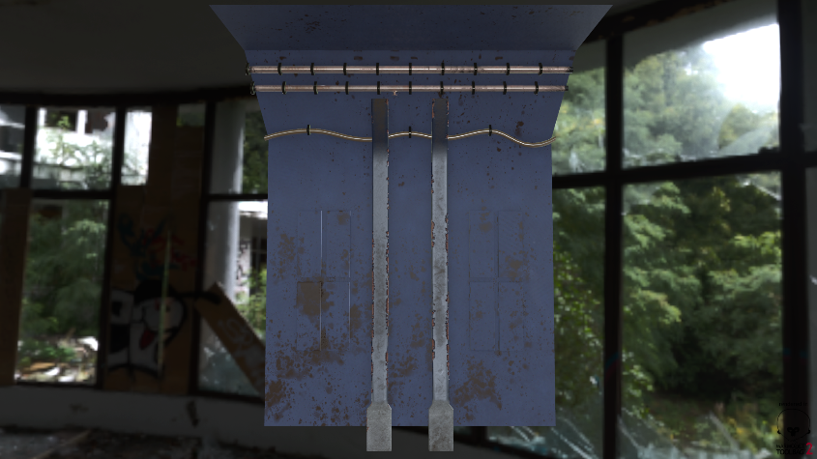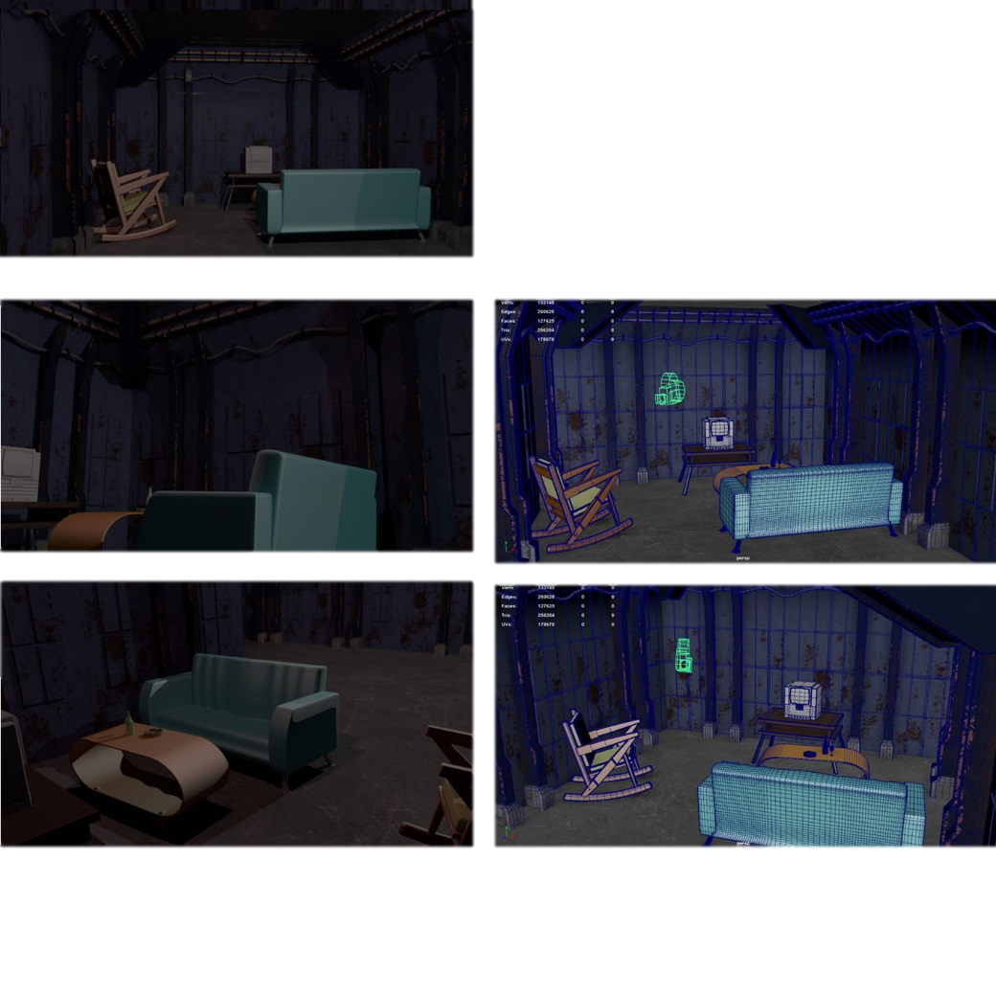The Topology and Polycount is also displayed with two screenshots from Maya.

Concepts Comparison

With the original 3D environment plan the main intention was 10 rooms and multiple floors which was a very ambitious plan so I decided to upon starting asset creation that I would change the end result plan to just one room. This decision helped me focus on each individual assets as well as ensure that the textures within the environment are as good as they can get.

In pre-production there was not a huge amount of planning for the asset creation within Maya but I ensured when modeling that each model had good Topology as well as a relatively low polycount which helps in multiple factors including; File Sizes, UV unwrapping and possibly Engine based rendering like in Unreal Engine 4.

Lots of the concepts and key visual themes within the pre-production document helped me to develop and model the assets created, I specifically used the planned mood boards of the visual themes to help me with the intended materials that go into making the textures.

Overall I think that it was a shame that the original plan for the 3D environment had to be changed because it was too ambitious but I am more than happy with the outcome of the room, because when creating the environment, I had to make the surrounding walls it means that those same asset scan be reused if I was to finish the rest of the intended environment.

Technical & Aesthetic qualities

Within the pre-production the environments look and style was taken into heavy consideration and researched with primary and secondary research to ensure that it had a target audience that it could be aimed towards, I think that the finished environment stuck to the planned visual themes and designs well.

When creating the environment and the assets to go into the environments I made use of various different 3D modelling and texturing software’s so that the models would turn out as expected, these different software’s includes Zbrush, Substance Painter and Xnormal.

An improvement that could have been made is spending more time on UV unwrapping so that texturing could be easier, as well as improving UV unwrapping I would have liked to finish texturing all the assets within the 3D environment.

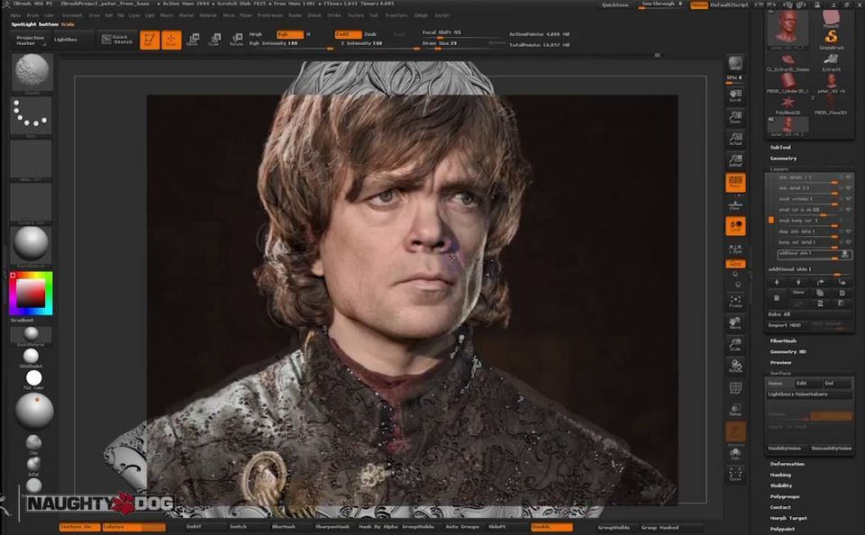

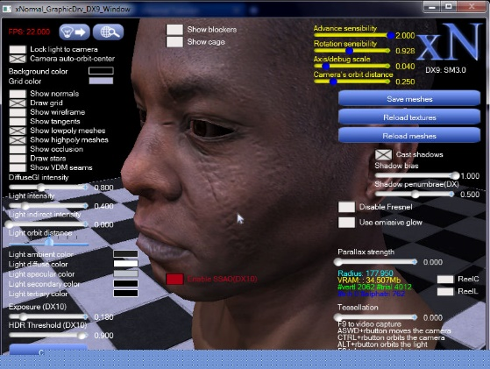

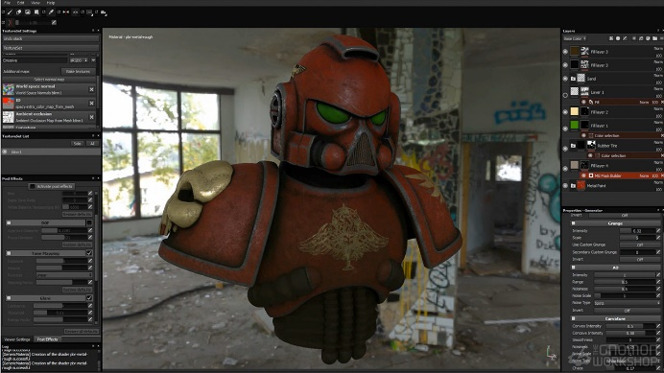

**Workflow & Time management**

The environment modelling workflow was directly helped and influenced by the file layouts, within the 3D Environment folder I made four separate folders to layout different aspects of the whole project, these folders include Models, Textures, Images and Planning & Write-ups. With these folders and files organized it saved lots of time when choosing where to save, import, export or load files from and it also helps incase other people work on the models or environment because they should be able to navigate the folders to find the necessary files. management was planned out with a table that clearly shows the intended schedule for asset creation and environment compiling.

|  |  |  |  |  |  |  |  |  |
| --- | --- | --- | --- | --- | --- | --- | --- | --- |
|  | Week 1 | Week 2 | Week 3 | Week 4 | Week 5 | Week 6 | Week 7 | Week 8 |
| Asset 1 |  |  |  |  |  |  |  |  |
| Asset 2 |  |  |  |  |  |  |  |  |
| Asset 3 |  |  |  |  |  |  |  |  |
| Asset 4 |  |  |  |  |  |  |  |  |
| Asset 5 |  |  |  |  |  |  |  |  |
| Asset 6 |  |  |  |  |  |  |  |  |
| Environment |  |  |  |  |  |  |  |  |

