

**Contents**

1. **Test tables**
2. **Test tables**
3. **Date seen**
4. **Versions**
5. **Game tested**
6. **Final Testing table**

Maze Game Bug Report

Listing and detailing each bug within the game with sufficient information about how and why it occurs along with possible fixes for problems that occur.

Mark Woods

3/21/2016

**Test tables**

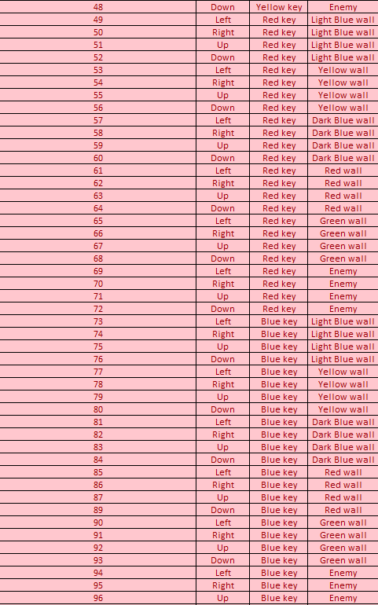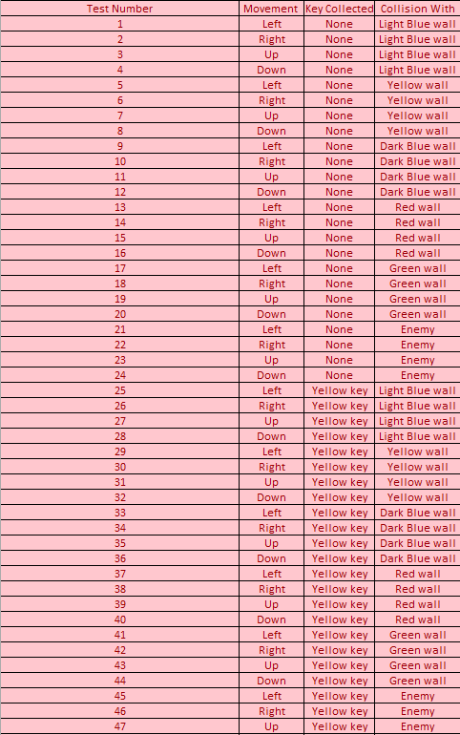The initial test table shows all possibilities within the game, this helps to show why certain tests where cut out to make up the second test table.

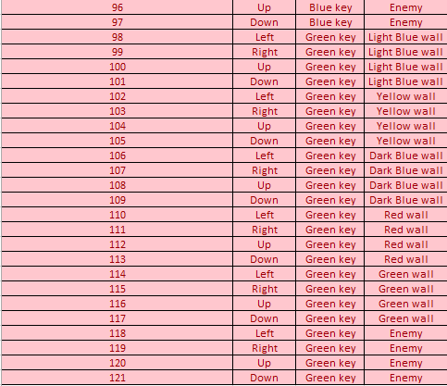

**Test tables**

These secondary test tables are made to reduce the amount of tests done within the game. With the initial test table there are over 120 tests but the same testing results can be reached with less than 20.

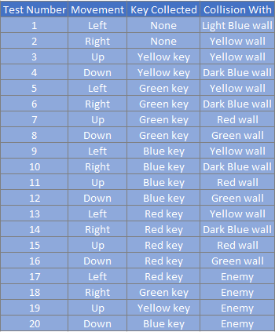

**Date Seen**

Each bug has a date and time that it was found, this helps to manage the amount of work done and the bugs that have already been fixed or tested. The test numbers correspond to the final test table which documents all the tests that were checked and the bugs that were found.

|  |  |  |
| --- | --- | --- |
| Test Number | Date | Time |
| 1 | 21/03/2016 | 11:12am |
| 2 | 21/03/2016 | 11:14am |
| 3 | 21/03/2016 | 11:21am |
| 4 | 21/03/2016 | 11:22am |
| 8 | 21/03/2016 | 11:32am |
| 10 | 21/03/2016 | 11:35am |
| 11 | 21/03/2016 | 11:44am |
| 12 | 21/03/2016 | 11:52am |

**Versions**

**Operating System and version**

The operating system of the computer I used to test was Window 7 and the Build / version was 7601. This should not affect the game testing although it is still important to document just in case. For example a windows error with Gamemaker is error 10049 which is to do with the public or private IP of the user, to be fixed it requires the local port to be changed to allow the debugger to connect.

**Software title and version**

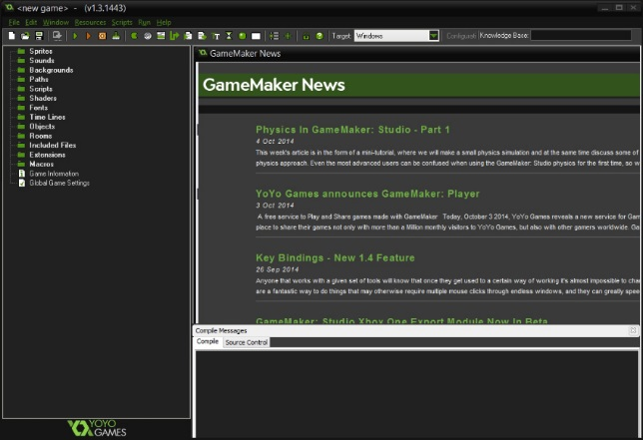The software used to make and run the game was Yoyo games’ Gamemaker and the build / version was v1.3.1443, this is important to the game because the game might be played differently with a different version or software. An example of a problem with software is the Gamemaker error Code #1341, this error happens when opening Gamemaker which will then say that the user no longer has a license key, to fix this the license must be updated to a newer version which allows for the software to be opened properly.

**Other installed software**

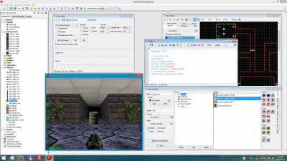On the PC that was used to conduct the games tests there was no external software installed that interacts with the testing process, if there was it could affect the way the game is ran or played. An example of third party software for gamemaker is LateralGM which is a free program that gives the user a different way of editing the gamemaker files outside of gamemaker, this can cause problems like error 215 where the program will not open and to fix this the plugins within the software must be organized and possibly uninstalled.

**Hardware information**

The hardware specifications of the computer used to test are:

* Processor: Intel(R) Core(TM) i5-2400 CPU @ 3.10GHz
* Video Card: AMD Radeon HD 7000 series
* RAM: 8.0 GB
* Operating System: Microsoft Windows 7 Enterprise Edition Service Pack 1 (build 7601), 64-bit

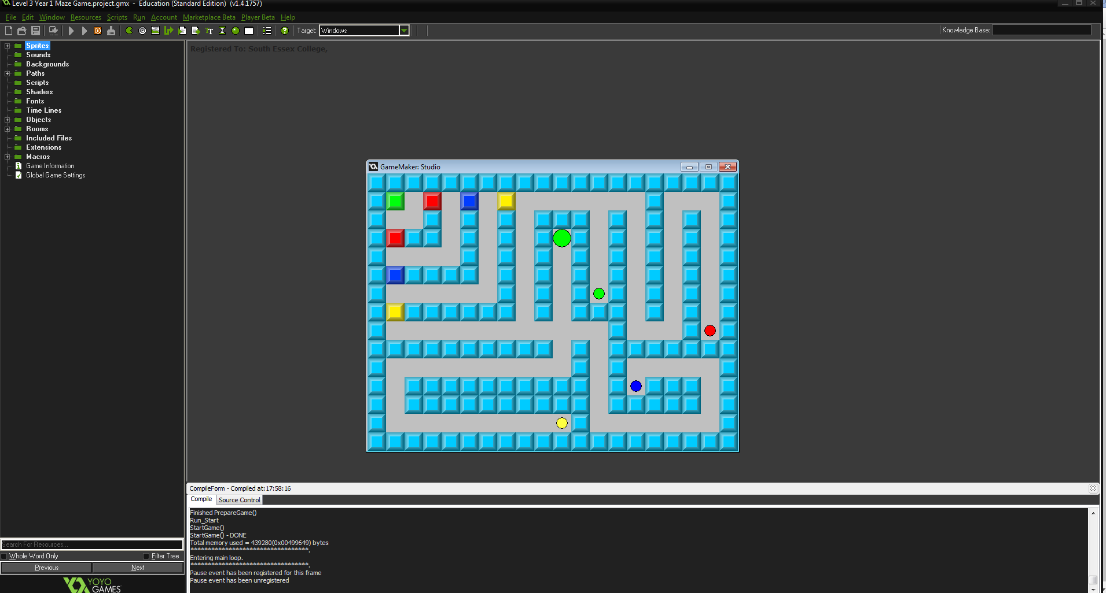The game that I was bug testing was a maze game with a large green ball for a player and coloured walls which could be unlocked with their respective coloured keys.

The following table on page 7 is the finished tests carried out on the game build, The table shows the test number which shows the amount of tests done, the Test value carried out which references the secondary test table in blue, a short summary of the expected outcome of the tests, a short summary of the actual outcome of the tests and the proposed fixes for the bugs that were found with the game build.

The Red within the table shows the tests that turned out unsuccessful resulting in bugs being found and the green displays the tests that were done and resulted in no bugs being found.

