Unit 13 Understanding the computer games industry

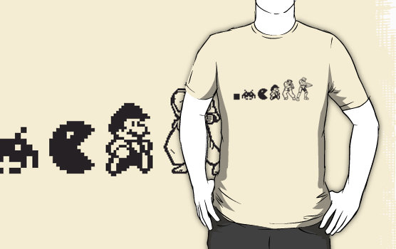

**Contents**

1. Game publisher
2. Game developer
3. Indie Game developer
4. Business models
5. Job roles
6. Market & Industry trends
7. 38 Studios
8. Laws and regulations
9. Contractual obligations
10. Contractual obligations
11. Contract types
12. Ethical obligations
13. Professional bodies
14. Professional bodies
15. 5 Year plan
16. Risks & Contingencies
17. References & Show reel

**2K Games**

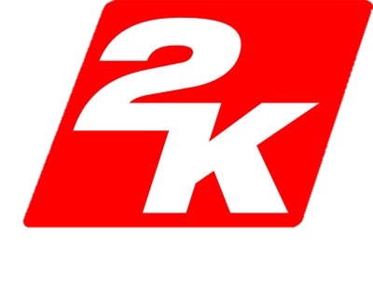2K games are a popular video game publisher who are known for a lot of their successful titles like; Bioshock, borderlands and XCOM. Founded in January of 2005 they have worked on almost 300 games and were nominated for the BAFTA Awards for their video game Borderlands 2, The job of a video game publisher is usually to be the marketer, distributor and the publisher, in some cases the games that they publish are developed internally and not by a separate game developer.

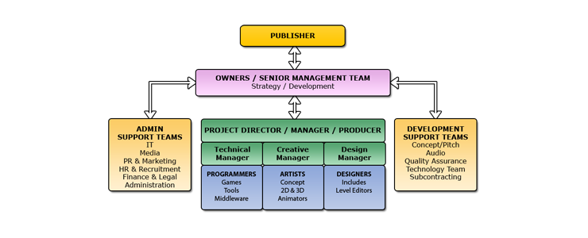

Their most popular games have sold very well including Borderlands 2 which according to Gearbox Software CEO Randy Pitchford "sold well over 12 million units". Along with Borderlands 2 2K games are also well known for the NBA 2K series of games they have been publishing annually since they acquired the IP from Sega when 2K games was founded.

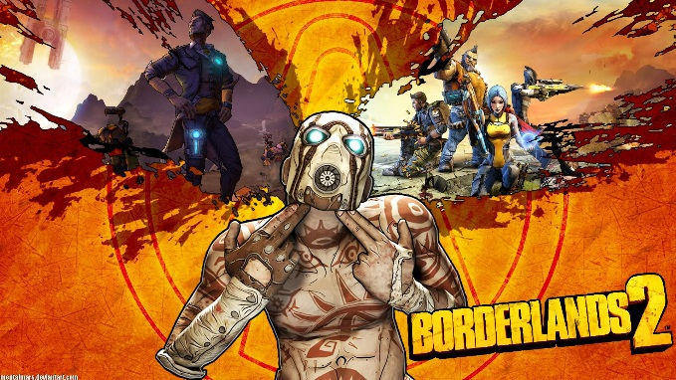

Since there is a lot of work that goes into making a game from start to finish and marketing, distributing and publishing it, 2K games have many different studios including studios specifically for sports games.

**Valve Corporation**

Valve are a hugely popular video game developer that are known for games like Half-life, Portal and Left 4 Dead which all run on their famous engine called the Source engine. Founded in August of 1996 Valve has made more than just games because they are also well known for their software distribution platform Steam which gets roughly 9-10 million users logging on each day and the company as a whole is worth about 2.5 billion US dollars.

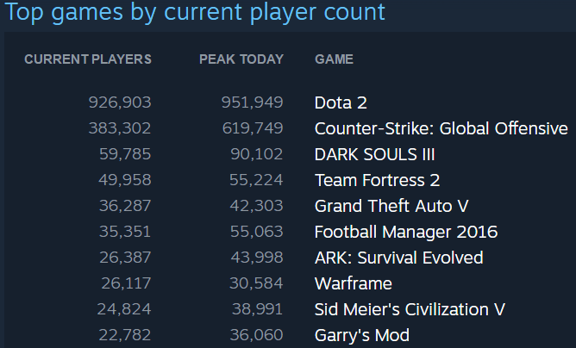

Their job as a video game developer is to Develop and create video games, A video game developer does not need to handle almost any of the marketing or distribution instead they focus on idea generation which they then pitch to a video game publisher, in Valves case they are a video game developer and a publisher so they handle everything internally without having to go to a different company to raise the money for the game or to get the game distributed.

There are many different job roles within a game development company from the initial developer that comes up with the idea and usually takes that to the game artists to give them a rough idea of what the game will be about and for the developer to find an art style they like. At the other end of the games development are QA testers which are important to find bugs and errors in the game so that the finishing touches of the game can be put in.

**Double Fine Productions**

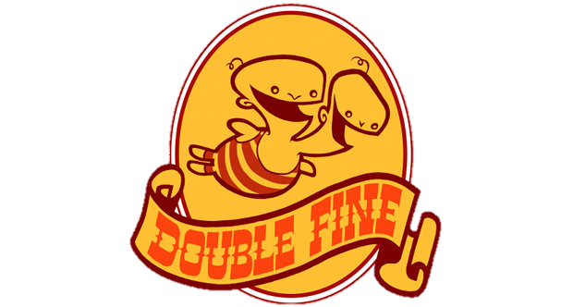Double Fine are a well-known indie studio known for their games like psychonauts, grim fandango and Brutal legend. Founded in July of 2000 they have had a lot of success with their games and unlike most big video game companies Double fine mostly rely on fundraisers to fund their games meaning the consumers that want to play their games invest money into the creation of the game.

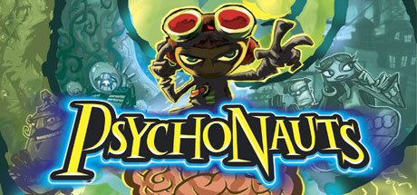Indie developers are usually known to be more reliable, likeable and honest than bigger developers because they often aren’t making games just to make money instead they are more attached to their consumers and care about each game they release. One of their most popular games Psychonauts has sold around 2 million units since its release in 2006 and has spawned a sequel because of the cult following it has.

**Business models in video games**

The business model of a game is the way that it makes money, these types include:

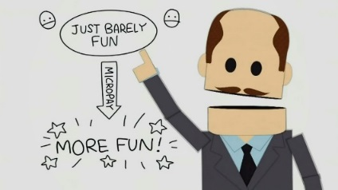**Premium** is defined as charging a fixed price for a game or an app and once someone has paid for the game there are no more necessary payments and the consumer has the whole game.

**Freemium** is where a game or app is free to play but the money is made through in app purchases (IAP). The freemium business model has become more popular with IOS and Android games like Candy Crush, Clash of Clans and Poker.

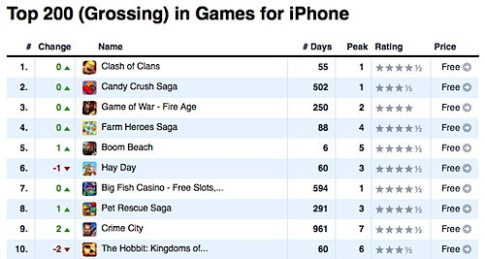**Ad supported** games and apps are supported by Ads so instead of making money through in game purchases or on initial purchases instead the ads that players click on or watch brings in revenue.

**Hybrid** simply means that any of the previous business models can be merged together like having a game with an initial payment that is also Ad supported or has in app purchases.



**Free to play**

Free to play games have become a widely popular business model for games and some of the most popular games played today are free to play including Dota 2, Clash of clans and League of Legends. These free to play games make money through in game transactions and don’t charge money for the games base content. Although being a very popular business model it’s also infamous for being Pay to win and aren’t always like by consumers. The free to play model is disliked because of the bad name it’s been given by popular IOS and Android games like clash of clans which is designed to cause the player to be inpatient and frustrated so that they use micro transactions to progress in the game.

Not all Free to play games use the same method to make money instead the game is purely separate to the micro transactions and a player can play through the entire game without paying money instead it is entirely optional to purchase cosmetics. Free to play games are a good business models for games but it’s an easy way to almost force players to purchase unnecessary items, cosmetics or cards.

**Job roles**

There are many different jobs in the gaming industry ranging from marketing a game to Testing a game for bugs.

**QA tester**

QA testers (Quality assurance) play early builds of video games and find bugs and problems within the game and note them down to be fixed or changed later on. People often think that they live the dream because they are playing video games for a living but QA testing is different to what people think it is because the salary is quite low and they don’t actually sit and play through the games instead they have to replay the same segments of a game over and over again to find bugs.

**Games programmers**

Games programming is a well-known job role in the industry because it is mostly up to them to get the game to function, it is a high paid job but they may only be needed for small programming jobs so they may be employed for a short time period like a freelancer. Giving the game the functionality to store and display points or have an enemy hit the player is the work of a game programmer but the work they do often goes hand in hand with the artists so that the coding fits in with the animation or the characters that have been developed.

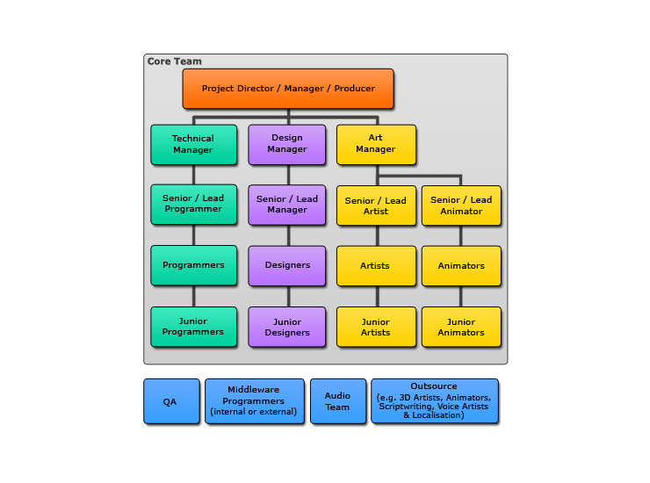**Sound designer**

Sounds designers are an important part of the game design process because a good sound designer can make all the difference for the game especially when the game is a specific genre like horror where the game might heavily rely on sound design to give the game the correct feel. Games like Elder scrolls Skyrim have good sound design because they use well known methods of sound design like playing tension building music when a fight starts or playing eerie music when the player is searching through a dungeon.

**Level designers**

Level designers have a job that usually goes reasonably unnoticed by the player when done well, Level design applies to any and all games and they don’t necessarily need levels to require a level designer because their work can range from designing a basic dungeon to designing a complex string of quests. Most level designers work closely with environment designers so that both the goals for the player to complete and the environment that the goals are implemented into match up.

**Market trends**

Market trends in the video game industry can range from Twitch streamers to the success of free-to-play games. Free to play games are a business model in the video game industry that has become very popular with mobile games but is also common with console and PC games, A game that used the free-to-play model to find success is angry birds, Each angry birds game is free-to-play but the first angry birds was ad supported and when the game became largely popular and sequels were made they decided to change business model to be entirely free because they could make enough money from merchandise involving the angry birds brand.

Market trends like let’s plays and streaming have become extremely popular within the past five years and it has evolved the industry with it because traditional advertising for games has started to be replaced with streamers and youtubers playing a company’s game and in some cases are paid to play their game because it may reach more of an audience through actual gameplay.

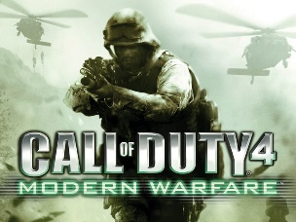

Modern Warfare

13.5M sales

**Industry trends**

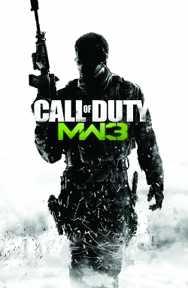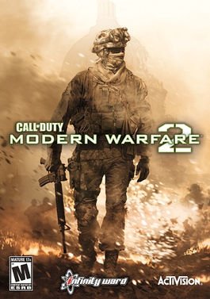Industry trends are similar to market trends except they are controlled by the industry, these trends can range from steam sales to sequels. Sequels are popular trends in the industry because once a company makes a successful game they usually want to expand it into sequels and possibly a franchise, examples of this are Assassins creed, Call of duty and Halo. Each of these franchises has started with one game and grew in popularity to spawn sequels, movies and separate mobile games.

Modern Warfare 2

23M sales

Modern Warfare 3

26M sales

Industry trends aren’t always looked upon by the consumer as a good thing because they can cause a company to continue to make sequels instead of trying new IPs.

Other industry trend is the popular Steam sales on Valves Steam service, they often have large quantities of games up for sale at discounts. They are often very popular and allow Valve to sell games at a lower price that usually would not sell many copies.

**38 Studios**

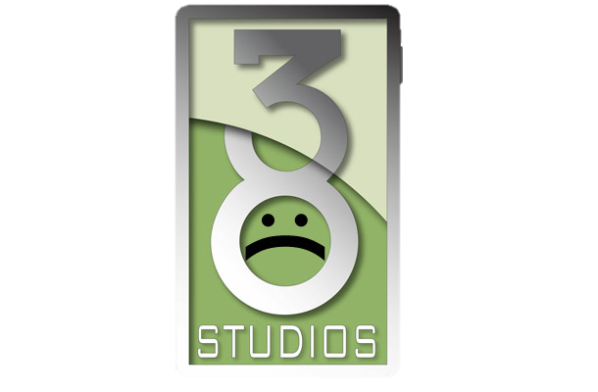38 Studios which was formerly known as Green Monster Games was an American entertainment and IP development company which was founded in 2006 by Major league baseball player Curt Schilling. The founder of the company Curt Schilling decided to name it 38 Studios after his jersey number. The company moved to Rhode Island after originally being based in Massachusetts and Curt Schilling decided to get a loan of $75 million to fund his new company.

In February 2012, the company released its only game called Kingdoms of Amalur: Reckoning, a single player action role playing game for several platforms. It began quite popular and was given positive reviews and sold roughly 330,000 copies in the first month, this rose to 1.2 million copies in 90 days. 38 Studios shut down a few months later. The failure of the controversial Rhode Island loan spurred investigations by the news media and the government.

**Laws and regulations**

**Intellectual property**

An intellectual property (IP) is an idea such as a logo, invention, names, images, artistic works, designs and symbols that are used in commerce. IP’s are used so that creators can have a way of showing that their ideas are their property and cannot be used without their permission. IP’s are protected legally with Copyrights (©), Registered Trademark (®) and Trademark (™).

**Copyright**

Copyright (©) is a legal right created by the laws of a country, Copyright laws differ for each country. A copyright will give exclusive rights to the use and distribution of original work, Copyright laws usually last for a limited time which is around 50-100 years added onto the life of the author or creator. Most Intellectual properties under copyright can be brought, sold and licenced on commercial terms, also the owner of the copyright decides the use of the IP and any unauthorised use of it is unlawful.

**Trademark**

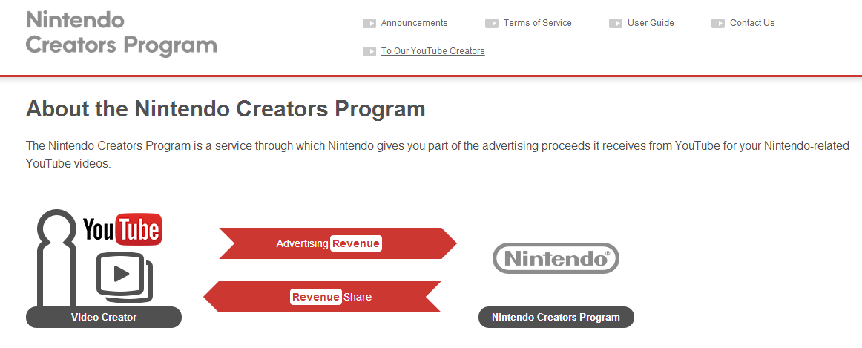Trademark (™) is a symbol or expression that identifies products or services, Trademarks are used to show the original source of the property that it is attached to. The trademark owner can be a business, legal entity or a single person, trademarks can be purchased and sold to allow a company or person to manufacture products related to or containing a brands material. An example of Trademark being held and enforced by a company is Nintendo holding their trademark rights for their products, they have lately been using their trademark rights to take down videos that include footage from their games, unless the creator of the video has agreed to the terms of Nintendo which include Nintendo getting the larger cut of the revenue from the videos.

**Contractual obligations**

**Employee-consultant agreements**

An employee-consultant agreements is the most common type of agreement and it exists between the game developer and whoever they employ, These agreements help to set out the terms of employment including:

* Benefits
* Non-compete
* Confidentiality
* Inventions

**Work for hire**

This agreement ensures that the rights for any work created by an external employee such as music, code or art belong to the one hiring the employee, these agreements cover the following areas:

* Outsourcing
* Subcontracting

Any work that is worked on by an external employee can be classed as Work for hire but it must fall into one of the categories that are detailed in the copyright act.

* Translation
* Instruction test
* Test
* Answers for a test
* Atlas
* Contribution to a collective work
* Complication
* Supplementary material

**Nondisclosure agreement (NDA)**

A Nondisclosure agreement contract helps protect the ideas and concepts that are not eligible to be protected by copyrights or trademarks. If an idea is discussed with someone who has not signed a Nondisclosure agreement then it loses its trade secret and becomes public domain.

**Development Contracts**

These contracts are used between publishers and external developers, they help to outline the responsibilities that each of them has to the other. These contracts cover all issues involved in the publisher-developer relationship, these issues include:

* Financial terms & royalties
* Project elements
* IP ownership
* Marketing plans
* Distribution plans
* Obligations of each party
* Licensing use

**End User License Agreement (EULAs)**

This agreement is between the publisher and the user and it is used to protect the publisher, the purpose of the EULA is to stop the game from being resold and rented It also helps protect the from the software causing damage to computers, data or reverse engineering.

**Terms of Service (TOS)**

The terms of service for a game are the "rules" that the user has to agree to so that they can play the game, these terms allow the publisher to make sure that their game is being used legally and it allows them to ensure they cannot be sued for things that they speak about in the terms of service.

**Contract types**

## Zero hour contract

A zero hour contract allows employers to hire staff with no guarantee of work, the employee will only work when they are need by the employer and they will get paid depending on the amount of hours they work.

## Full Time / Part Time

A full time contract is a form of employment which guarantees the employee a set amount of work and also come with certain benefits like bonuses and holiday leave that part time contracts usually don’t have. A part time contract carries less hours a week than a part time contract and the shifts are usually rotational, workers are considered to be part time if they work less than 30 to 35 hours a week.

## Freelance

Freelance workers are employed for a set amount of time by companies to work on something but they are usually self-employed or part of another company but the employer that employs them is still responsible for their health and safety.

## Fixed Term Contract

A fixed term contract lasts for a specific length of time that is set in advance and they employment ends when the task is complete or when a specific event takes place.

**Code of conduct**

The code of conduct is what game development companies have to follow to keep to their moral and professional standard, these main sections of code of conduct include the main principles, Workplace standards and leadership standards these are used to ensure that the whole company are under these roles no matter how high up they may be. All of these rules ensure that each member strives to increase their respect and recognition of the entire game development community, they also are held to workplace standards like Workplace safety and fairness to other employees throughout the company. Just like codes of conducts used in other scenarios like the Army it helps to keep each employee to specific standards in everything they say and do so that the integrity of the company and the integrity of all game developers is withheld.

**Ethical obligations**

**Violence**

Violence in video games often spawns a debate about whether games influence people to go out and commit crimes because they saw it in a video game, today there a lot of video games that involve violence on some level but the rating systems like PEGI and ESRB allow for the games to be legally sold with age ratings so that if a young person ends up playing an 18 rated game the companies can’t always be held responsible. Overall a large amount of people agree that video games are too new and rapidly changing to know for sure if they have drastic effects on children and teens.

**Rating**

PEGI is the company that handles the rating systems for games in the EU, when a game is finished it is sent to PEGI and they test it to find out the age rating that fits it. A games age rating is very important to the game and when the game is being developed it is important to make sure that the games assets keep to the age rating that the games targeted with. If the age rating of the game comes out to be higher than the designers intended it can cost a lot of time and money to go through the game and change things that may give it an incorrect rating.

**Education**

On the contrary to violence in video games influencing people the ability that games have to teach people is growing more and more, games that educate as well as entertain are often called edutainment and they are often serious types of games because they have a strong purpose to teach the player instead of pure entertainment. Games that aren’t made to educate can also teach the player things like twitch reflexes and hand eye co-ordination.

**Stereotyping**

Stereotyping in video games is a common thing, the main reason why this occurs is because nowadays the video game industry is commonly targeted towards a male audience which means that many people think that this is stereotyping against women. Common stereotypes include thinking that mobile games are not “real games”, women don’t play games and that men only enjoy games with monotonous violence.

**Addiction**

Addiction has become more of a popular topic as video games have started to become a more common thing in our media, many video games today are criticized to be addictive which cause players to forget to not step away from the game occasionally and spend time working, eating or going outside. Games these days follow requirements that mean that they have to implement things to make the player want to stop playing or at least nudge them so they know that they should take a break.

**GTA San Andreas Hot coffee**

Hot coffee was a file released for GTA San Andreas in mid-June of 2005, once the mod was installed it allowed the player to enter their virtual girlfriends’ house and engage in a crudely rendered, partially clothed sexual intercourse mini-game. The mods name refers to the way that the unmodified released game refers to the cut content, this happens when the player is outside their girlfriends’ house and they are asked if they want to come in for coffee. The controversy over this hidden code within the game came to public attention because an attorney called Jack Thompson denounced the game in the media as if the Hot Coffee modification was widely available and easy to stumble across for children. This caused the game to be pulled form stores across the USA and re-rated by the Entertainment Software Rating Board (ESRB), Rockstar where then forced to remove this feature and release an 2nd edition of Grand Theft Auto Sand Andreas.

**Professional bodies**

**Bafta**

BAFTA started out as the British film academy when it was founded in 1947 by a group of directors that were major figures of the British film industry. Since then the company has become involved in more than just films and they have branched out to Games, television and young game developers.

Now the British Academy of Film and Television Arts is an independent charity that promotes, supports and develops the art forms of the moving image, they do this by rewarding people for their work, inspiring people to work in film or game and benefiting the public. They are most known for the ceremonies the hold to award people for their work, as well as the ceremonies they also have year round learning events and initiatives to inspire and teach audiences of all ages across the UK, Los Angeles and New York.

**IGDA**

The International Game Developers Association is the largest membership non-profit organisation that supports individuals developing games, the goal if IGDA is *“To advance the careers and lives of game developers by connecting members with their peers, promoting professional development, and advocating on issues that affect the developer community.”* They have chosen to focus on certain points including:

* Advocacy: Make change in our industry by identifying and speaking out on key issues
* Networking and Community: Connecting members with their peers, both geographically and functionally
* Professional Development: Promoting constant improvement of our craft
* International Reach: Expanding the global community of game developers

**5 year plan**

My five year plan will start with the first year of a level 3 games development course where I will hopefully learn the basics of game development and look at a vast range of different aspects of games or jobs in the industry, this should help me find out the specific types of game development that I enjoy. After year 1 of level 3 I will move onto year 2 which I will then be able to choose what aspects I want to focus in on like coding, modelling, rigging, animating or art. Things that I learn during year 1 of level 2 games development can help me to understand more about year 2, all the things about game development I hope to learn during the level 3 game development course include: pre-production, modelling, game testing, digital graphics, game engines, bug reports, job roles, budget and planning. Along with all the work necessary to accomplish a merit or distinction during this course I will work on lots of different aspects like show reel and coding in my free time to increase my understanding of game development and to build up a collection of all that I have worked on, this will all be held on a website that I create to keep it all together and organized.

After the level 3 games development course is completed the grade I get should help me to look for university’s to apply to and I will also be travelling to conventions and meetups with people in the game development industry to learn and discuss opportunities that I may have, Along with meeting people I will continue to follow tutorials and guides of software in my free time to expand my knowledge of game development. The courses that I will apply to will be much more specific to a part of game development because the previous course should teach me enough about the basics. The different universities that I will look at applying too include:

**University of Essex University of Cambridge**

The course that I will be looking for will be a 3 year course specifically for coding within game development, this three year course will end my five year plan with the necessary requirements to find and apply for my dream job. The course that I will apply to will be Computer Science with Games Development BSc (Hons) during this course I will learn:

**Year 1**

KC4000 - Relational Databases (Core, 20 Credits), KF4006 - Procedural Programming (Core, 20 Credits), KF4007 - Object Oriented Programming (Core, 20 Credits), KF4009 - Web Technologies (Core, 20 Credits), KF4010 - Computing Fundamentals (Core, 20 Credits), KF4011 - Systems Analysis (Core, 20 Credits)

**Year 2**

KF5002 - Web Programming (Core, 20 Credits), KF5008 - Program Design and Development (Core, 20 Credits), KF5009 - Machine Learning and Computer Vision (Core, 20 Credits), KF5010 - Operating Systems and Concurrency (Core, 20 Credits), KF5011 - Computer Networks and Control Systems (Core, 20 Credits), KF5012 - Software Engineering Practice (Core, 20 Credits)

**Year 3**

KF5000 - Professional Placement (Engineering and Environment) (Optional, 120 Credits), KF5001 - Professional Placement (One Semester) (Optional, 60 Credits)

**Risks & Contingencies**

There are many risks involved in my five year plan including failing a course, not being able to join a course and being indecisive on a path of game development. To counteract these risks I will create contingency plans to help me in case the five year plan does not go as planned. These contingencies include backup universities that I will look at applying to which include:

-University of Oxford

-King’s College London

As well as these plans the course that I will be applying to may not work out which means that I will plan for other similar courses that I can apply to which will hopefully help me to learn the same if not similar tools and skills, these course include:

- Games Design and Art - 1 yr(s)

# -Computer Science with Games Development BSc (Hons)

These contingency plans should help to counteract the risks meaning that I can safely follow my 5 year plan without worrying.

**References**

http://playwiremedia.com/developers/Mobile phone image of ad

http://bgr.com/2014/11/06/south-park-video-freemium-games/ South park Freemium game image

http://www.tacticalgaming.net/hq/news/2013/developer-spotlight-2k-games 2K game logo image

http://www.macnn.com/articles/14/04/01/opportunity.to.try.before.you.buy.earn.rewards.through.ads.seen.as.selling.points/Top 200 grossing IOS games image

http://i2.wp.com/pmcvariety.files.wordpress.com/2013/08/twitch-to-livestream-the-e3-event.jpg?crop=0px%2C2px%2C600px%2C334px&resize=670%2C377

**Showreel**

http://markwoods10.wix.com/level-3-games#!3d-modelling/c1x9v