Version 0.1
May 26, 2016
Presented by: Mark Woods
50202088
Level 3 games development

3D Modelling assignment 2 Contents
Proposal and Planning

3D Modelling assignment 2 Contents

Contents

BrainStorms
- Idea Generation
- Multiple Mind Maps

Environment diagrams
- Floor plans
- Environment description

Target audience
- Primary and secondary research
- Explanation of target audience

Key Visual themes
- Art style
- Deterioration & Colours

Pre-visualisation drawings and designs
- Concepts
- Mood Boards

Legal & Ethical considerations
- Morality & Age ratings
- Copyright & Software licensing

Technical constraints & considerations
- Software constraints
- Workarounds

Brainstorms
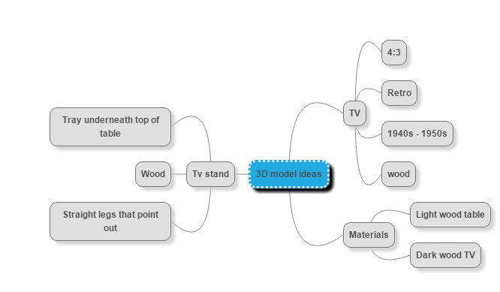
I started my idea creation by making a quick mind map where I wrote down the ideas for the model including the time period it is from, the materials that it will be made from and the basic design of the asset. The Mind map I made to generate my idea for a 3D model also helped me to find what Images I wanted for the mood board. Mind maps are important part of the planning process because it helps to generate ideas and store them in a Nice to look at diagram instead of a large daunting paragraph. For the environment mind map I decided to Think about the pros and cons involved in each different environment choice so that I would not regret my choice later on, For a big project like a 3D environment I wanted to make sure that I covered all my bases for planning in case I need to go back to check information about my ideas when I am developing the model, textures or rendering.
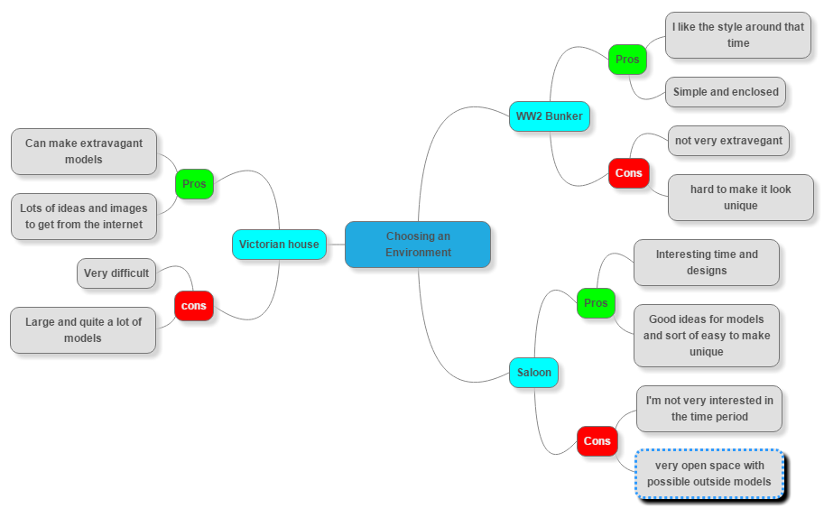

Prospecting Mechanism
[Describe your prospecting mechanism.]

Pre-event Follow-up

Environment Diagrams
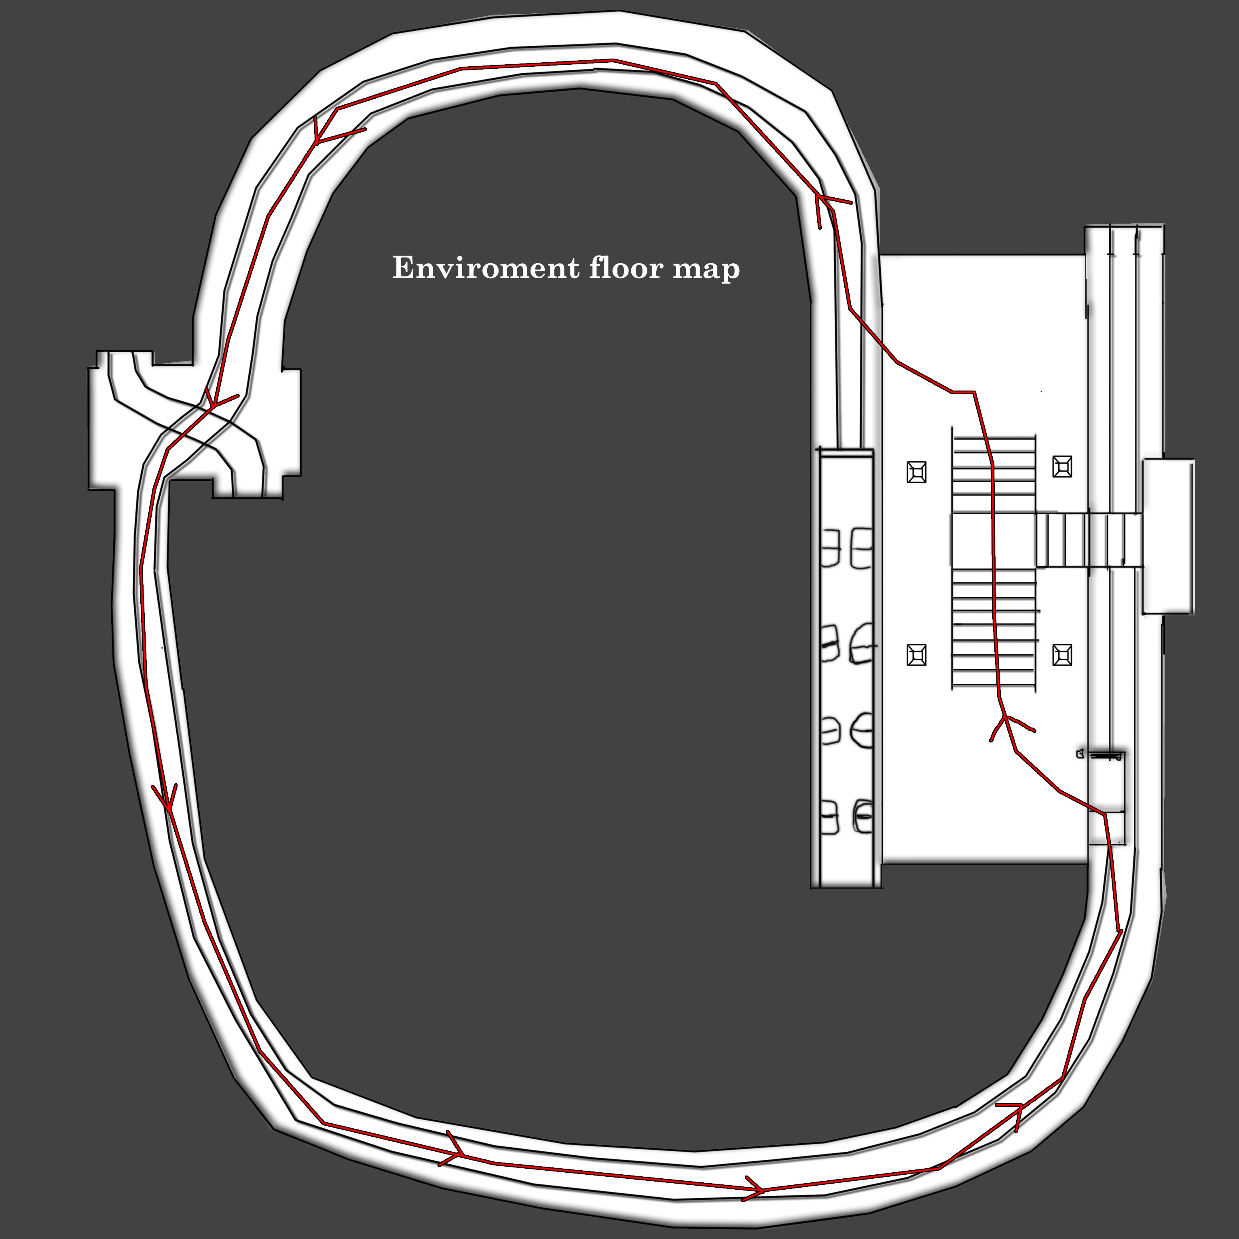
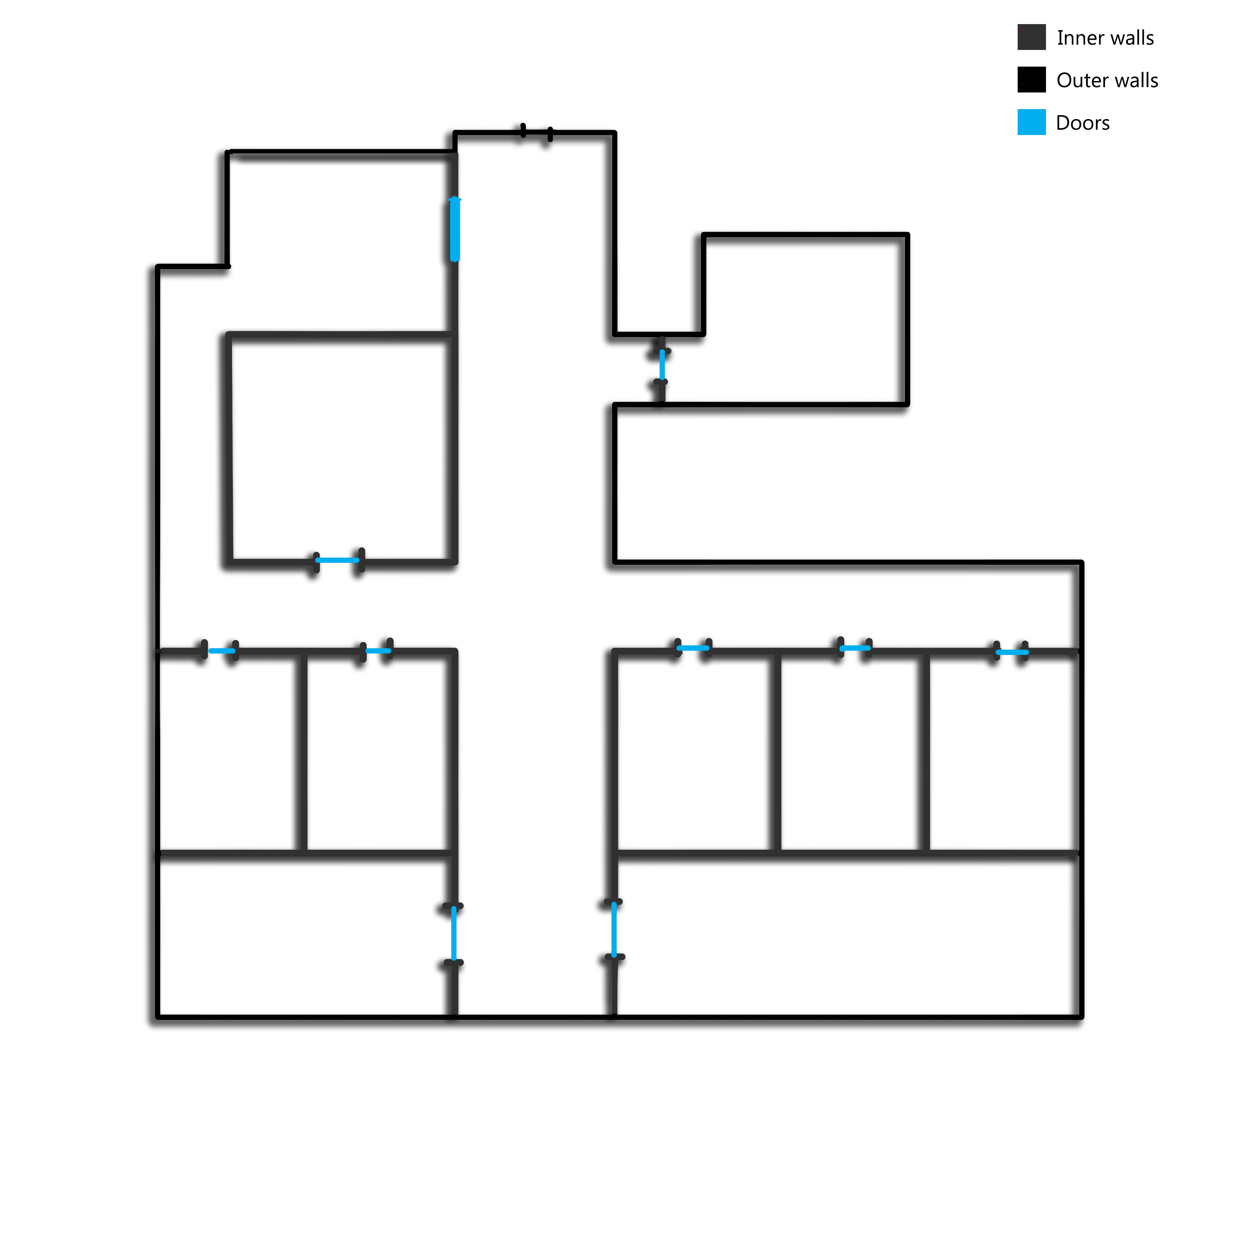
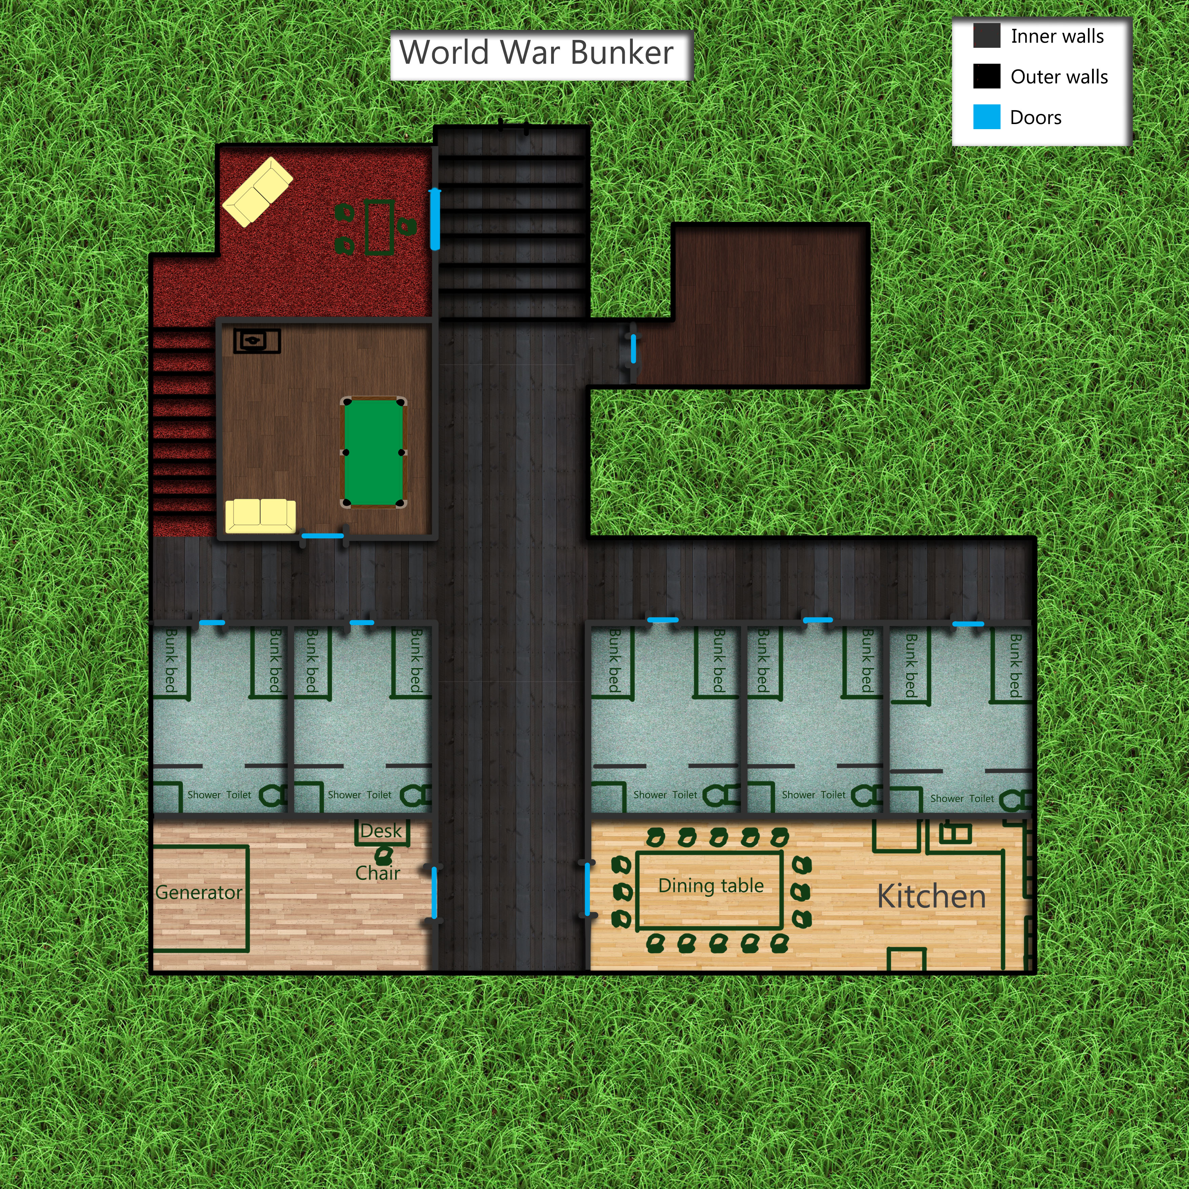
Floor maps are a great example of environment diagrams that help understand and layout the environment in an easily understandable top down map of the whole layout. The first floor map on the left is for underground train station environment that I had planned for but choose not to do it but to postpone it and instead go for the World War bunker environment. The Train tunnel environment included 6 assets; Bench, Train, Door, Snack Machine, Generators, Tool box. For the chosen floor map of the World War Bunker I chose to put more detail into it and marked out furniture, doors and stairs, this helped me plan out the environment to a much higher detail for later use. The maps also help with the direct modelling of the environment because the can be directly imported onto an image plane within Maya.

Target Auedience

A lot of research goes into the target audience of the environment including primary and secondary research, for primary research I had group of peers answer a selection of questions about the types of environments and styles they like which helped me decide on the type of assets that will be included in the environment and the style that goes into them so that the target audience is the most broad and still sticks to what the target audience want.

As well as Primary research I also did some secondary research to find out the most popular game genres that involve the same style as my 3D environment These Games include:

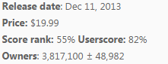
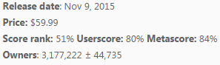
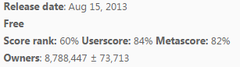
Rust
War Thunder
Fallout 4

Key visual themes
The target audience helps to understand the key visual themes because I already have the information to know the preferred visuals for the environment.

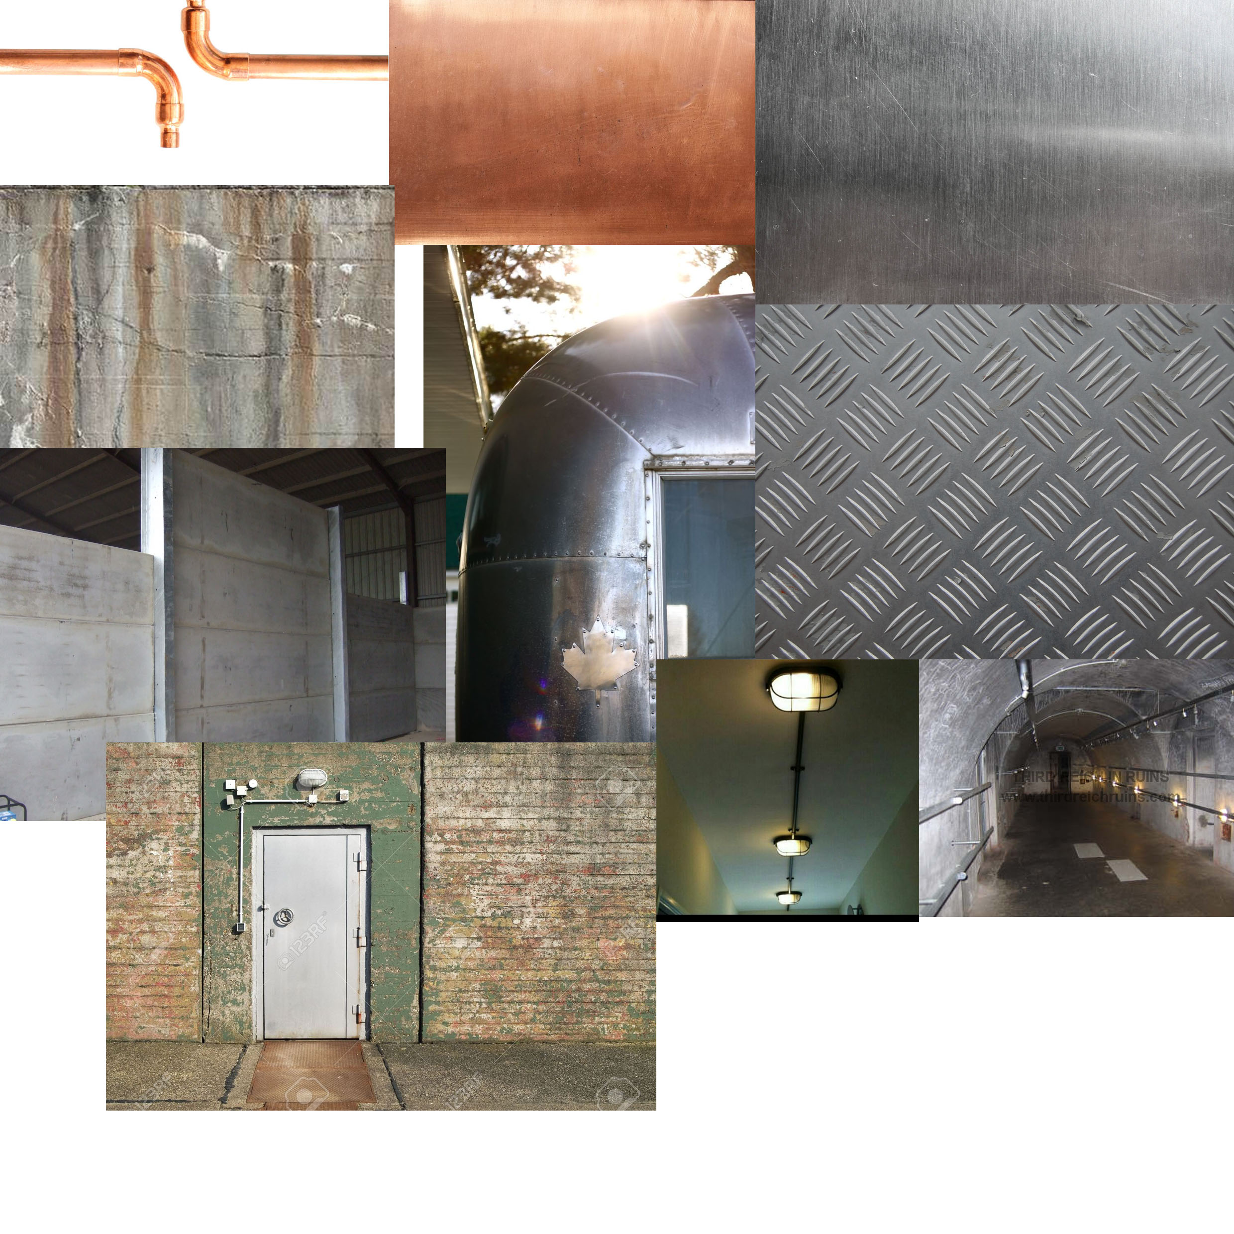
For the chosen environment which is a world war bunker the key visual themes are industrial Colours and materials like steel, rust and copper which will help to make the environment look authentic.

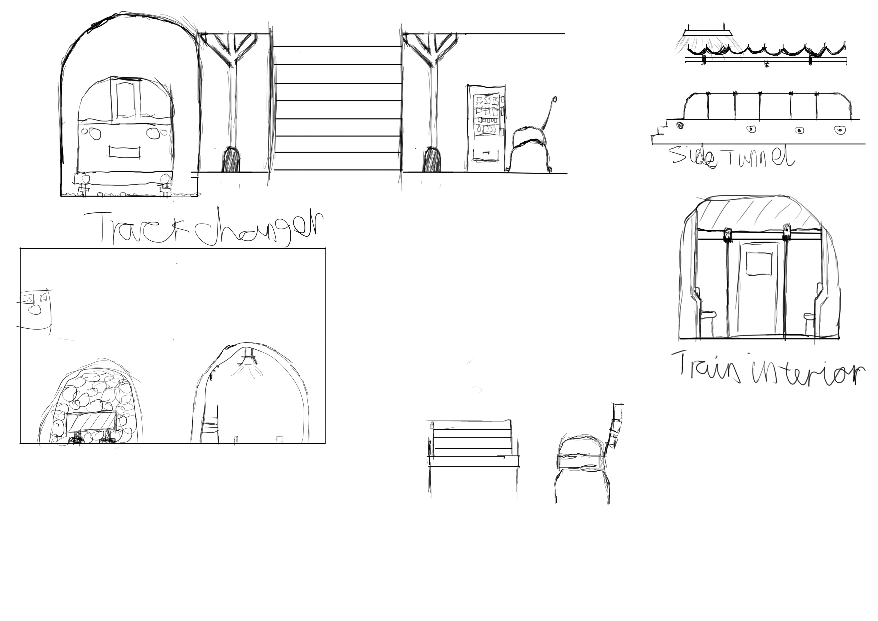
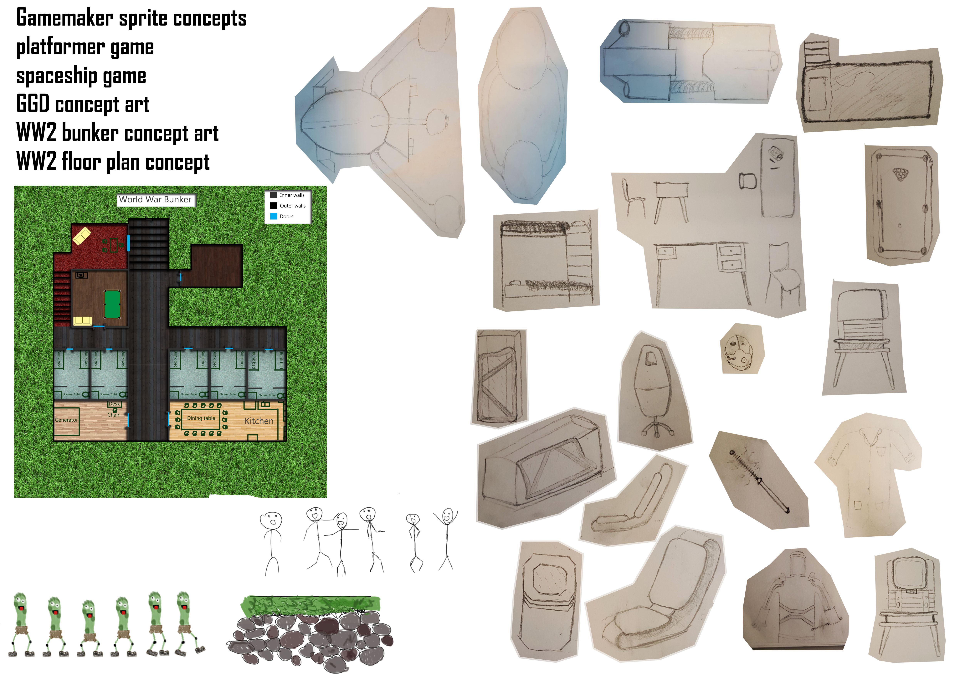
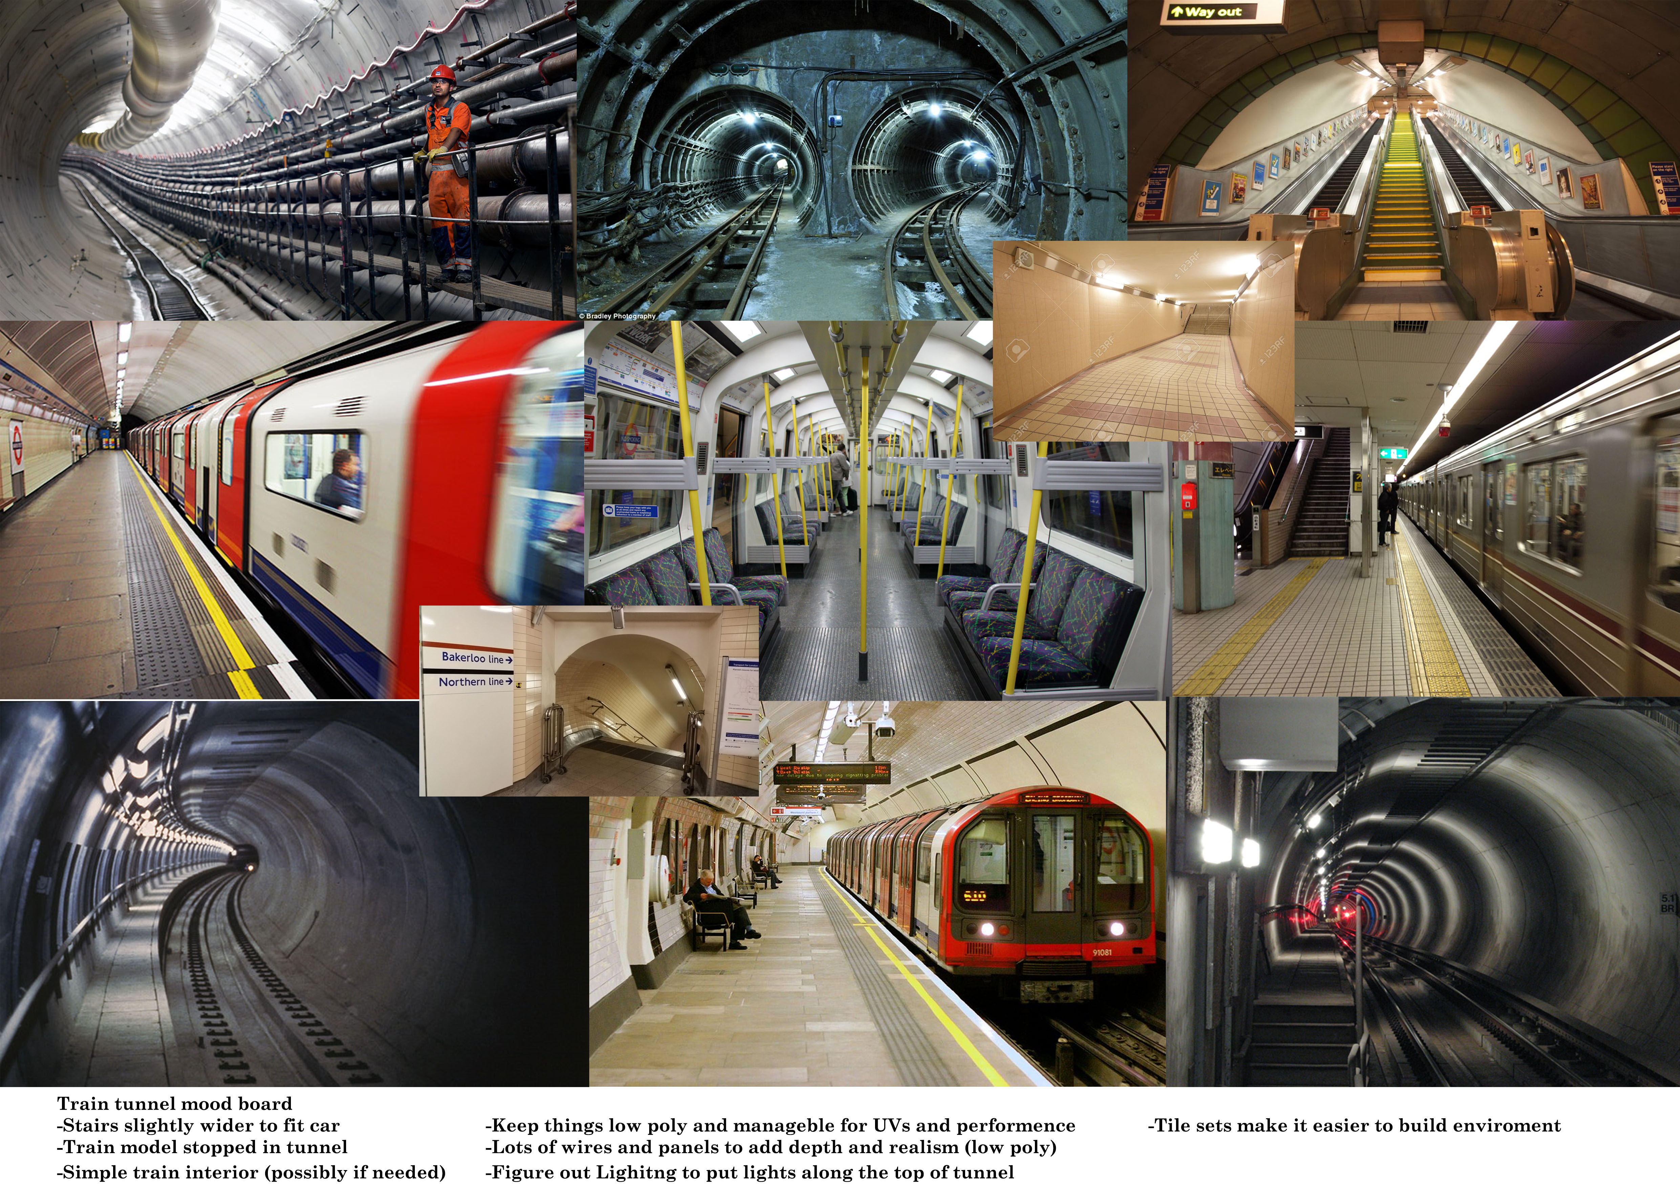
Pre-visualisation drawings and designs



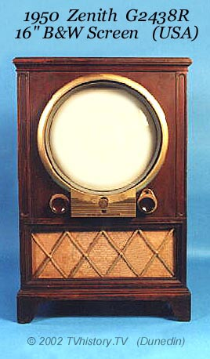

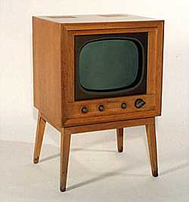
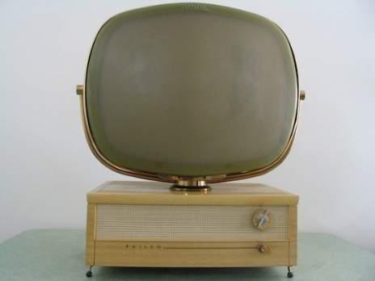

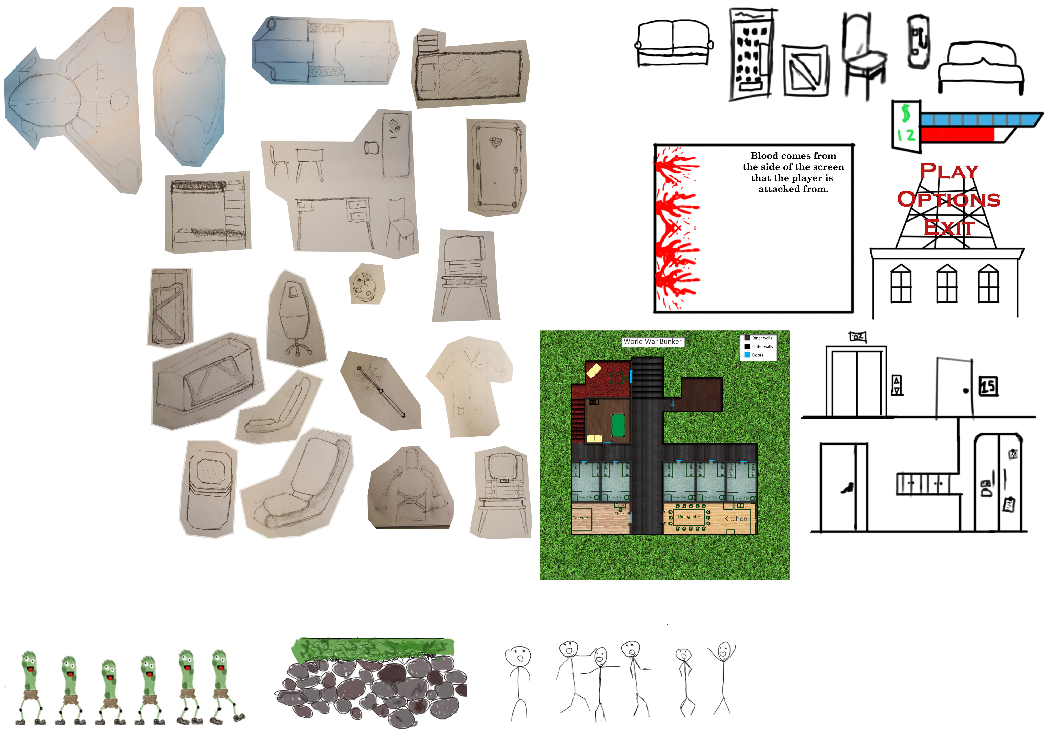

Legal & Ethical considerations

-Morality in games development
It is important to consider the possible effects that the games plot and choices can have on the mental health of some players, the subjects that games can bring up can resemble real world situations and possibly influence players that they should act similar to their characters in the game. Violence towards figures in the game can correspond to violence towards figures in real life e.g. Police.

-Age Ratings
The age rating of the game is very important because it keeps the messages that the game may convey away from people too young to understand or take in responsibly. PEGI is the age rating systems used throughout Europe to give video games a rating that fits the content within the game, The PEGI ratings are: 3, 7, 12, 16 and 18 but there are also other tags attached to games that show the specific possibly harmful content the game contains.

-Copyright
Copyright is important to consider when making games because it helps to protect peoples work from plagiarism, this also means that when you have ideas for your game it can be very close to other ideas and elements from other games which means doing research before is necessary. Copyright can apply to Intellectual property and certain game features.

-Software Licensing
Software licensing refers to the use of software legally whilst making a game. Programs like Photoshop have licenses and subscriptions that are necessary to pay for to use the software legally, some free software does not require any licenses but may have specific rules for content creators that use their program like having to share profits with the developer of the software or not being allowed to make publicly available content at all.

Technical constraints & considerations

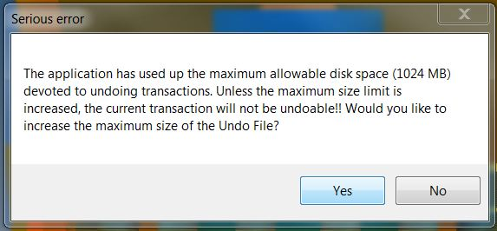
Because of the specific software that is used in creating the environment some constraints hold us back from certain capabilities that other software may give us access to, Common problems like memory space occur often because files can easily become too large to manage, to counteract this software that compresses files can help when transferring them through USBs or OneDrive’s or even backing up the files which is a very important habit to get into so that hours of work won’t be lost.

With Maya being the main program used for the 3D environment it means that most work will be done with it including Modelling, UV Mapping and Rendering but outsourcing some of the work to other programs is also a good idea because some programs are specifically for a few purposes as opposed to Maya which is quite a broad software that involves almost all aspects of modelling. Similar programs like Zbrush and Substance Painter can do specific jobs like texturing to a better standard so to avoid constraints in Maya the Textures will be done externally and then imported back into Maya to be grouped together to make the final models.
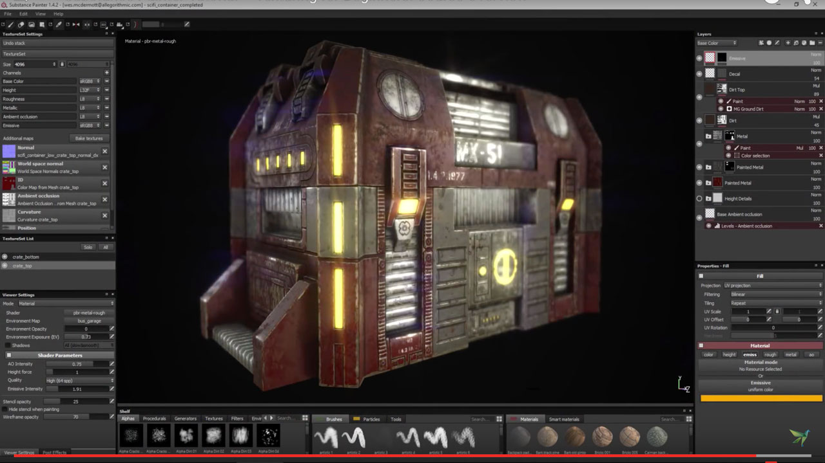

Wix Blog Posts

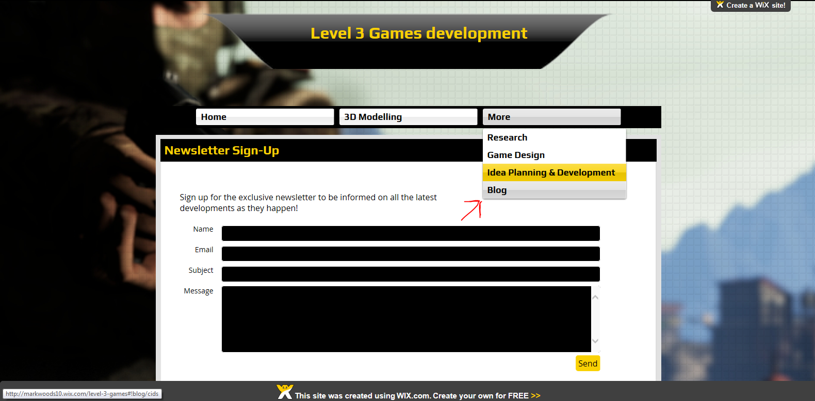
http://markwoods10.wix.com/level-3-games

