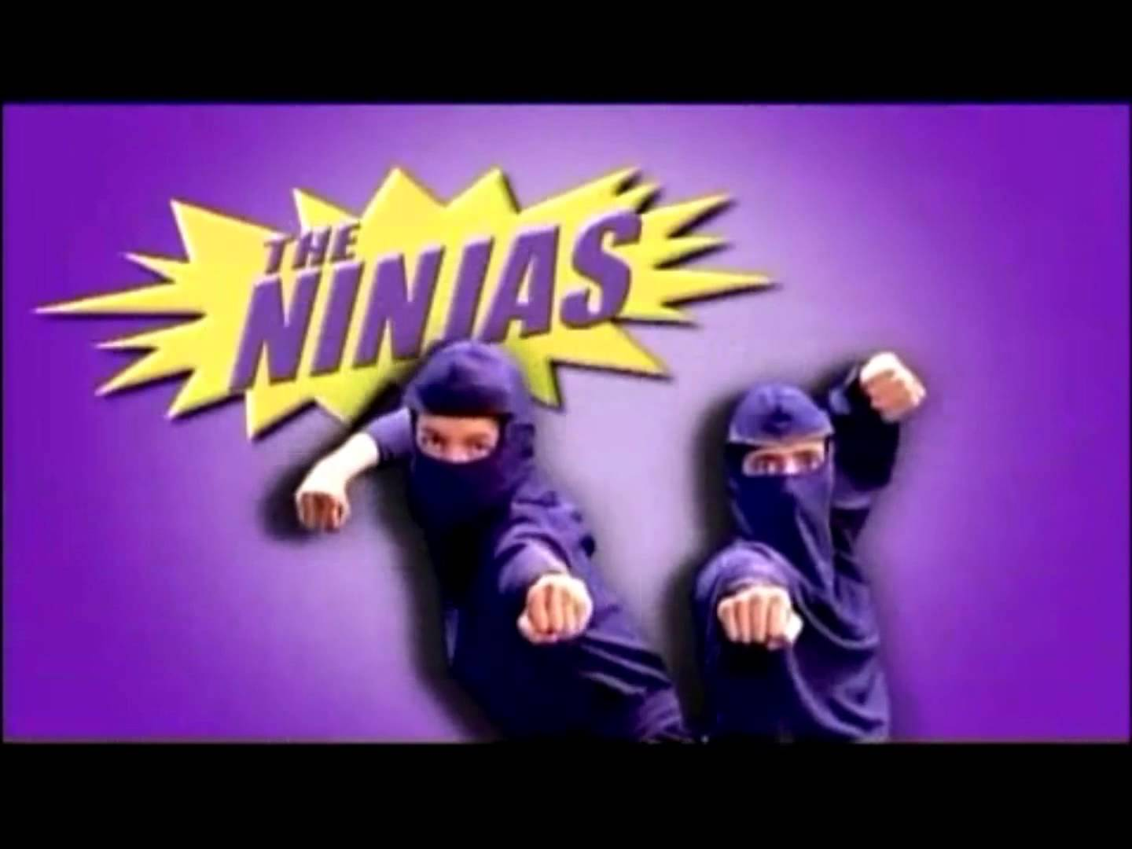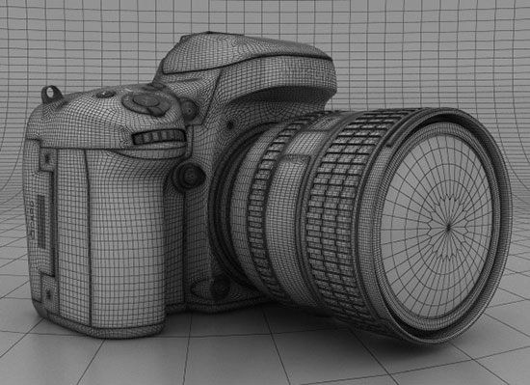

Understand theory and applications of 3D

Unit 66 3D modelling

# Contents

Applications of 3D Page 1-4

Displaying 3D model animations Page 5-6

Geometric Theory Page 7

Mesh Construction Page 8-10

3D development software Page 11

Constraints Page 12



# Applications of 3D

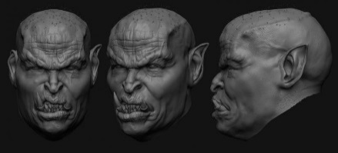**Models**

Models like this one of an orcs head are constructed in 3D modelling software like Maya or 3DSMax, these programs provide the user with the tools to create whatever they can imagine in a 3D space which can then be used in anything from Films, games, architecture or education. Most 3D modelling programs also allow for the user to configure tools within the program to suit them for example they could create their own toolbar to use for modelling or shortcuts that allow them to use tools like edge loops or beveling quicker and easier.

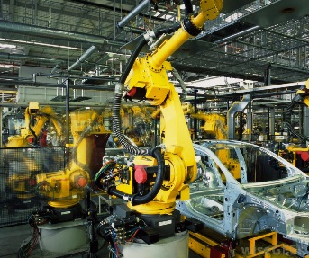

**Product design**

Product design is used in business for example the Car industry and even the Deodorant industry, These businesses use 3D modelling software to visualize the products in a 3D space instead of just with concepts but perhaps a more important use of 3D modelling software is the direct use of a product model In the production process, this is done by using the developed 3D model to tell a machine how to build the product for example car parts can be individually modelled and used by a machine to precisely make the product in mass quantities to exact standards.



**TV Animation**

Animations in TV are usually constructed using various 3D modelling software like 3DSMax, Maya and Blender but they are usually much more subtle uses then big budget films. 3D software is used for simple things like TV adverts and Transitions like the Sky Logo, during a transition the channels logo is shown and the Sky logo usually has a 3D model of the logo where the camera is circling around and bright Colours are exploding from behind.

**Film Animation**

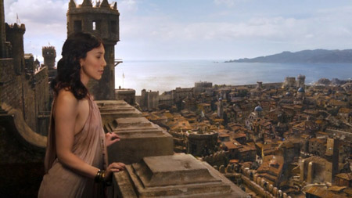Film animations is a little broader than TV animation because it is used in a whole plethora of films from live action to purely animated films, Films like Avatar are a good example of the use of 3D modelling programs in film because throughout most of the film there is a large amount of CGI used. When the Na’Vis are shown on screen they are purely Computer generate which is a good example of the uses of 3D and how lifelike organic things can get. The more subtle uses of 3D come with large establishing shots like in Game of Thrones where the whole of Kings landing is shown, course an entire city can’t be built for just the one shot so 3D modelling programs are used instead which when done well usually go unnoticed by the audience.

**Web**

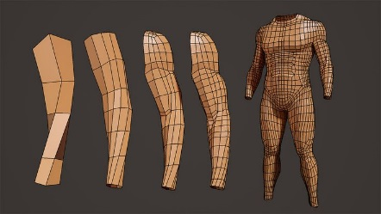Websites like YouTube are the most popular place to see other people’s videos because it allow for anyone to upload anything they like, this means that across the website there are a lot of uses of 3D such as popular YouTube accounts like FreddieW, Sam&Niko and CGMeetup. The web is a great place to find entertaining videos using 3D modelling software but it is also a great place to learn about various different types of software, online tutorials make up a large amount of the videos on YouTube and they help millions of people expand their knowledge on 3D modelling.

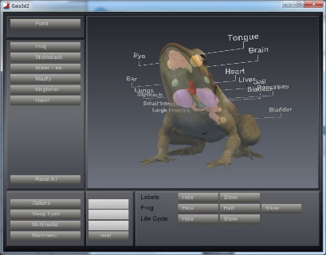**Education**

3D modelling programs can be used to make learning experiences for students that allow them to see something in 3D and interact with the different parts of that object, for example the biology of an animal like a frog can be modelled and made into an interactive learning experience where it can be dissected to help students learn and revise.

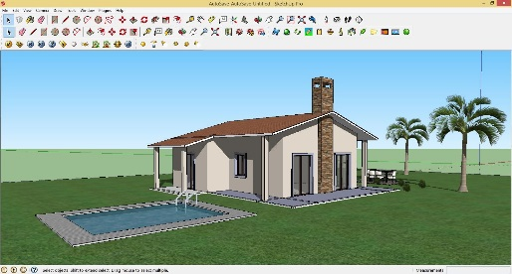**Architectural walk-Through**

Architectural walk throughs are a common use of 3D modelling software and they are essentially prototypes of buildings and structures that can be shown to help develop and plan ideas. The common program that is used for this is google SketchUp because it has built in tools that architects need when making structures like the dimensions tool, Tape measure tool and Offset tool. These programs can then be used to take screenshots of the prototype to show in a presentation or they can be used to explore the model and see all the detail.

**Games**

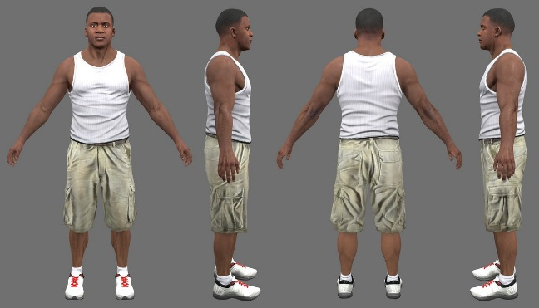Games are largely considered to be the most common use of 3D modelling programs because within a fully developed 3D Triple A title everything is modelled using a program like 3DSMax, Maya or Blender. Within these types of games there are organic and non-organic models like buildings, Cars and people, with each type of model comes a different type of complexity when it comes to modelling because with character modelling the character is usually planned to then be rigged and animated which implements complications such as topology which has to be very good so that the animations don’t stretch and skew the model in unwanted places and in unwanted ways. Character models are rigged using Human IK skeletons in Maya which contain points that represent human joints that are moved into place to emulate a human body. Games such as GTA 5 are good examples of software uses because the photorealistic art style of the game means that each and every model has to look as close to reality as possible specifically characters and vehicles which can be challenging to model well.

# Displaying 3D model animations

Within the 3D modelling software there are a number of ways to display the 3D model to help in the design process such as wireframe mode which can help see through the model and line parts of the model up e.g. building a house model. Another way of displaying a 3D model is using the shaded and textured display, this display gives the user a chance to see the 3D model in a way similar to the final model, this can help to understand what needs to be changed in the model and what doesn’t.

**-Direct3D**

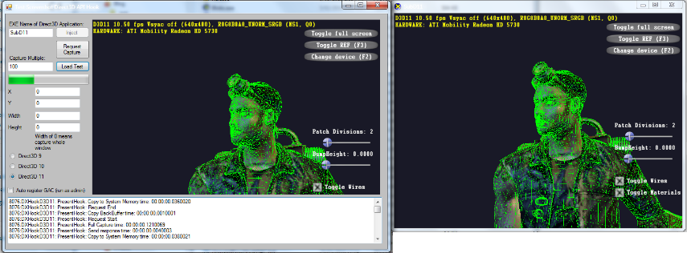Direct3D is a graphics application-programming interface (API) for Microsoft Windows and Xbox and is not supported for other platforms. It is used when rendering Three-dimensional graphics in applications where performance is important like in games and animations. If a graphics card has hardware acceleration it will be used to improve the performance of the rendering pipeline that in no particular order include Z-buffering, W-buffering, Stencil buffering, spatial anti-aliasing, alpha blending, colour blending, mipmapping, texture blending, clipping, Culling, atmospheric effects, perspective-correct texture mapping, programmable HLSL shaders and effects. DirectX and Direct3D are regularly updated by Microsoft to increase performance, add features and fix defects.

**-OpenGL**

OpenGl is a competing graphics application-programming interface (API) that has cross-platform support, which makes it more widely available for use as opposed to Microsofts Direct3D. Most GPUs since 2005 included either OpenGl or Direct3d built in, unlike Direct3D OpenGL is supported on mobile devices, and has a more broad use for many different platforms and not just games.

**Pipeline**

Modelling in 3D using OpenGL or DirectX with programs like Maya and 3DSMax creates Geometry as an input in 3D space, The geometry will always be there even if the space has been edited in any way e.g. rotations, remodelling etc.

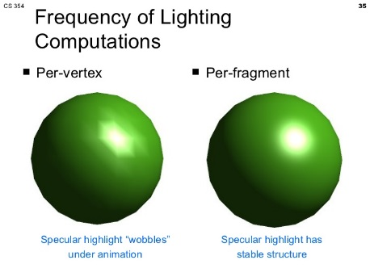Per-Vertex Lighting using DirectX or OpenGL with programmes like Maya and 3DSMax allow for the scene to have realistic looking lighting by using real life light geometric, if the lights within the scene are moved then the lighting on the model will also be changed.

Viewing the model using DirectX or OpenGL with programs like Maya and 3DSMax uses 3D world space to get the model coordinates that are transferred to a coordinates system based on where the camera is. This is because when rendering out a 3D model the 3D viewing area is now changed into a 2D view for a static image.

With the parts of the model that are not shown in the 2D final viewport the computer does not render those to save time which the user won’t notice because they have no effect on the final outcome render.

Converting the model to an image is also known as rasterization, Rasterization/Scan conversion is the process by which the 2D image space representation of the scene is converted into raster format and the correct resulting pixel values are determined.

# Geometric Theory

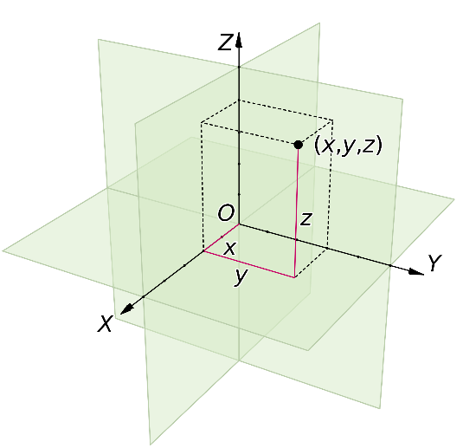

Cartesian coordinates are used to specify a location in a 2D or 3D space, with 2D space a Cartesian coordinate will contain 2 values to show the X and Y values but with a 3D space there will be 3 Values X, Y and Z. The Cartesian coordinates were invented by a French man called Rene Descartes.

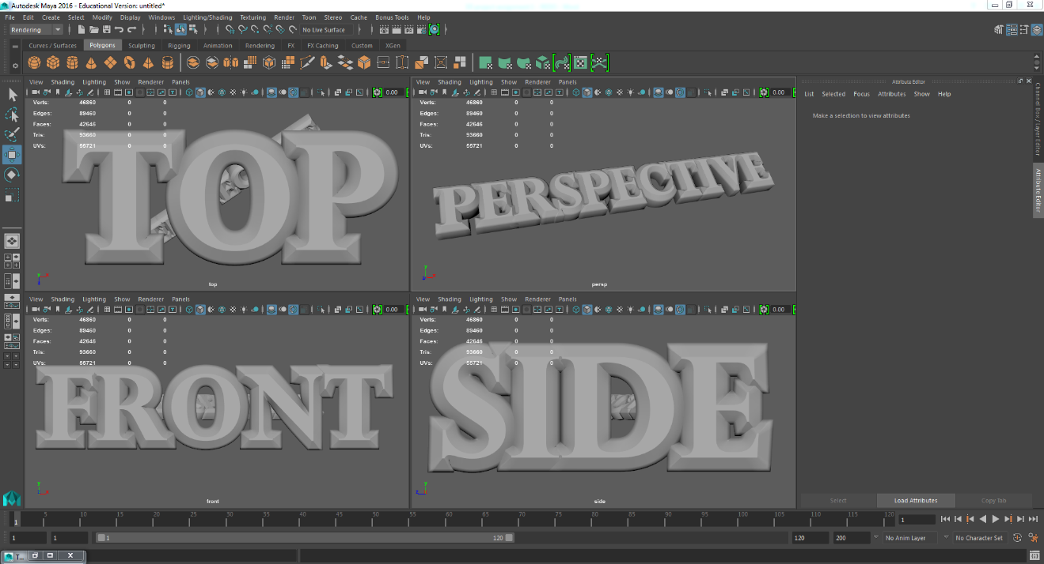Cartesian coordinates in Maya allow the user to see their model from multiple perspectives, there are four orthographic views by default that can be customized by the user the first is the Top view (X, Z) the second is the Front view (X, Y) the third is the Side view (Z, Y) the final view is a perspective view which allows the user to move around the 3D space with zooming, dragging and rotating.

# Mesh Construction

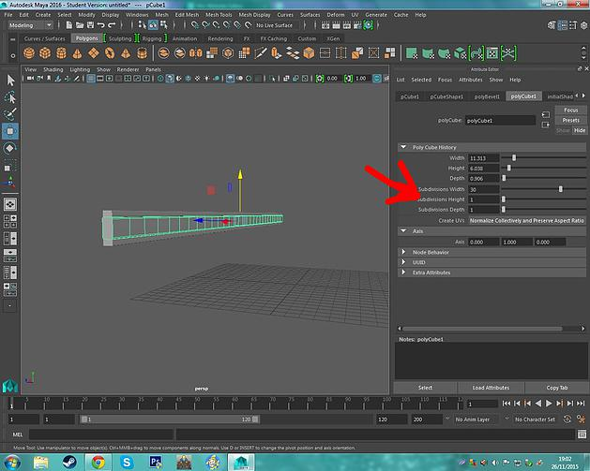

I began by creating a cube and shaping it to be longer, I made sure to add subdivisions along the length of the object because it is a very important part of the process of making an anything that you eventually want to bend. After an amount of subdivisions that I thought was adequate I selected the long edges of the object and bevelled them just a little, I then duplicated the object twice and placed both copies on the top and bottom of the shape and scaled down their height.

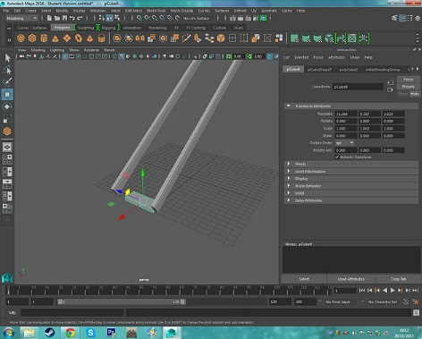

Once I liked what I had made I selected all the parts and combined them so I could then Duplicate it and move it over leaving a gap large enough for the steps to go. I then selected both sides and rotated those around 35 degrees to point upwards. I then began to start working on the steps themselves.

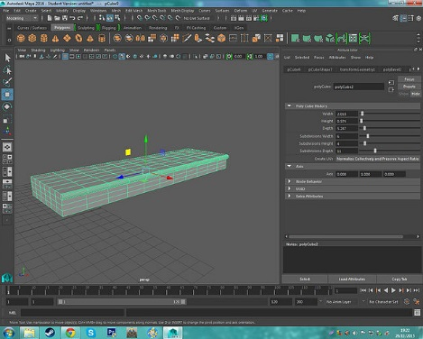

To start making the steps I first moved it into place inbetween the supports and used the freeze transformation tool in Modify so that I could then move the step away to work on it easier and the position where I put it will be remembered as 0,0,0 in the Transform attributes tab. I also decided to add subdivisions to the step because later on I want to bend the step slightly, I then Selected the face I had mad from the subdivisions and extruded it out, I selected the edges that were part of the extruded face and bevelled them to be smoother.

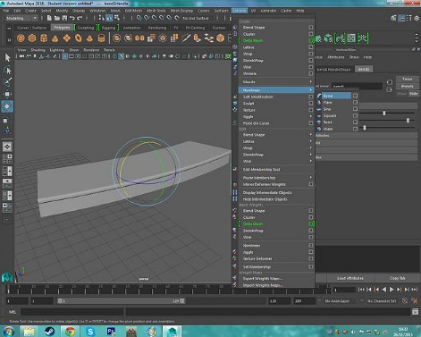I then wanted to bend it so with the step selected I used the bend tool in "Deform - Nonlinear" to create a bend, It was created upright so I had to adjust the rotation until it was in line with the step. After that I simply used the curvature slider to adjust the amount of bend added to the step. An important part of this step is to remove the bend object after I was happy with the result, I did this by deleting the history of the object in "Edit - Delete by type", and this also has a shortcut (Alt + Shift + D).

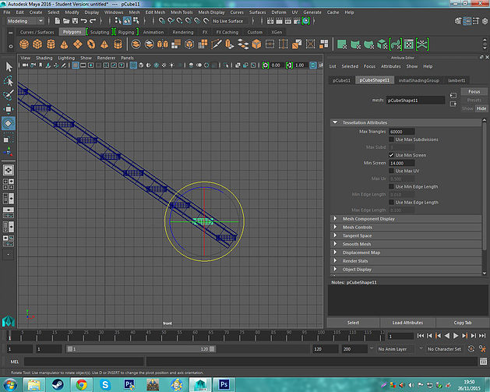Once I was happy with the step and made sure to delete the history I moved the step back into place and switched to a side view by pressing "Space" to see the 4 views and hovering over the side view and pressing "Space" again. I then went into wireframe mode to see through the objects by pressing "4", this helped me to adjust the position of the step and once I had the position set I Duplicated the step and moved it up and along the support to the place where I think the second step would go. Once I had done that a held "Shift" and pressed "D" until the steps reached the top.

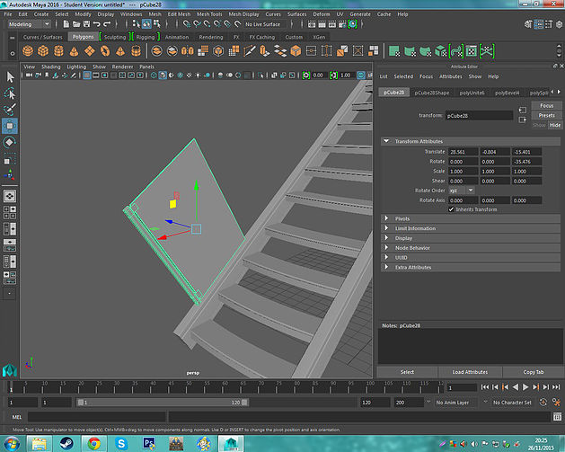

With the stairs almost complete I could bend it all now and end up with a spiral staircase but I decided to add railings to the side of the stairs. I started by making the metal support out of a cube that was scaled to be taller, I made small handles on the side of the object to hold the glass. I then made the glass and positioned the two parts together and I bevelled the edges with a very small fraction, combined them both and placed them on the stairs.

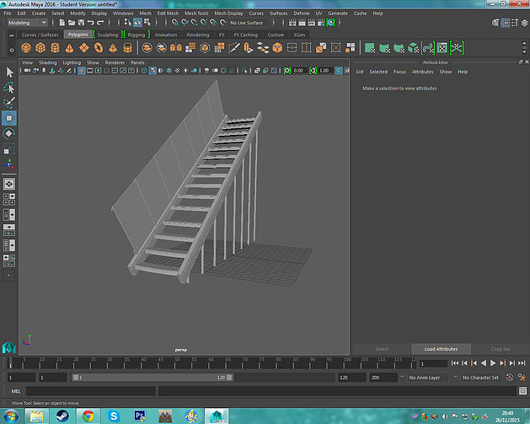

I then used the same technique I used with the steps where I duplicated the object and moved it up and along the staircase and held "Shift" and Pressed "D" until they reached the top. After that was done I quickly made some supports to hold the staircase up and placed them on the other side underneath the staircase utilising the same technique.

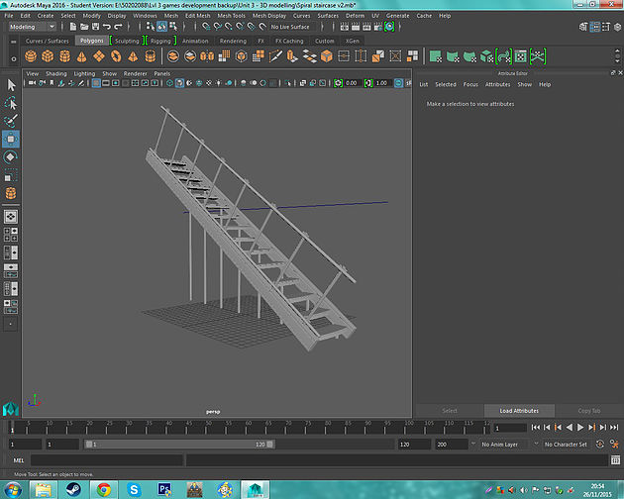

Because I was not happy with how the glass supports turned out I decided to delete them and replace them with some quick cylindrical supports.

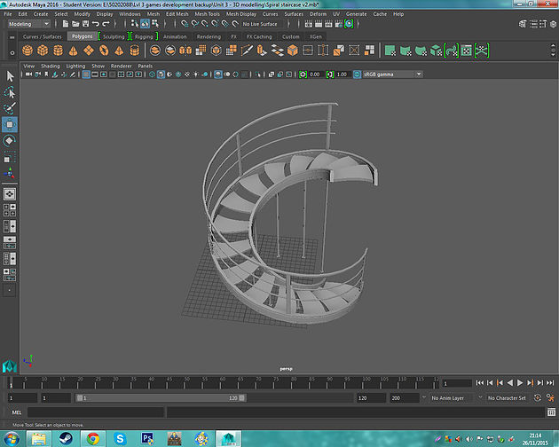The final step was to bend it all so I made sure to Combine all the parts first to insure that the bend would not skew parts of the model. After that I used the bend tool in "Deform - Nonlinear" and repositioned it to the right of the staircase and rotated it 90 degrees, this allowed me to change the curvature to 180 degrees which left me with a completed Spiral staircase.

# 3D modelling software

Google SketchUp is a 3D modelling software that was made on June 8th 2005 and can be used for a variety of different purposes such as; architectural design, interior design, film, and video game design. It is available in a free version called “SketchUp Make” and a paid version with more functionality’s called “SketchUp Pro”.

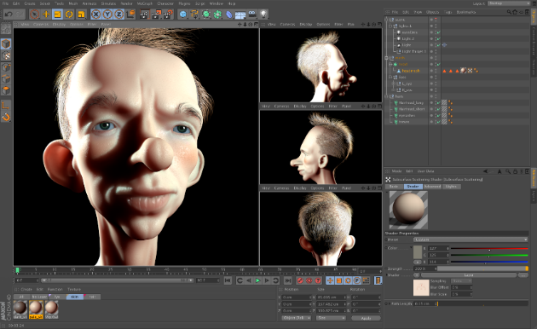

Blender is a free open-source 3D modelling software that was made in 2002 and received a large amount of updates since then to improve it and add features. Blender is a good tool to use for 3d modelling because it has a lot of good features that make it quick and easy to use for example; texturing, raster graphics editing, rigging and skinning, fluid and smoke simulation and particle simulation.

Autodesk Maya is a 3D modeling software developed in February 1998 and is widely used to create interactive 3D applications like video games, animated film and even for special effect purposes. It is one of the most popular 3D modeling software’s and has been used in a range of projects from Disney films to The Walking dead TV show and has received awards like the academy award for Technical achievement for the software’s fluid effects system.

Each of these different 3D modelling software’s has a different default file format that it uses when opening and saving files.

|  |  |  |  |  |  |
| --- | --- | --- | --- | --- | --- |
| Software’s | 3DSMax | Maya | Cinema4D | Lightwave | SketchUp |
| Default File Format | .3ds | .mb | .c4d | .lightwave | .skp |
| Supports .OBJ | Yes | Yes | Yes | Yes | Yes |

# Constraints

A main constraint of 3d modelling is the polycount, a polycount is the amount of 2d shapes that are used to build up to a 3d model, this can quickly become a restraint because the higher the polycount of a model the larger the file size will be which can make storing, moving and rendering the model more difficult. The 3D modelling software can also become a constraint if it does not support certain file types when exporting, importing or saving files this can be a problem when making 3D models or environments using less popular software or two types of software that aren’t compatible.

File sizes can also become very large which means that exporting and moving files to and from hard drives and software can take a lot of time, to counteract this certain file formats can be used to compress the file for easier use but it can mean that some software may not support the file format.

The time that I takes to render scenes into a 2D image can be very long considering the detail of the model and the quality of the final image, this can mean that just to render one still image it can take hours. This happens because when rendering the computer needs to figure out a number of things like Lighting, Ambient occlusion and reflectivity, something that can change the amount of time needed to render is a better computer because the better the hardware the faster the renders will be done.

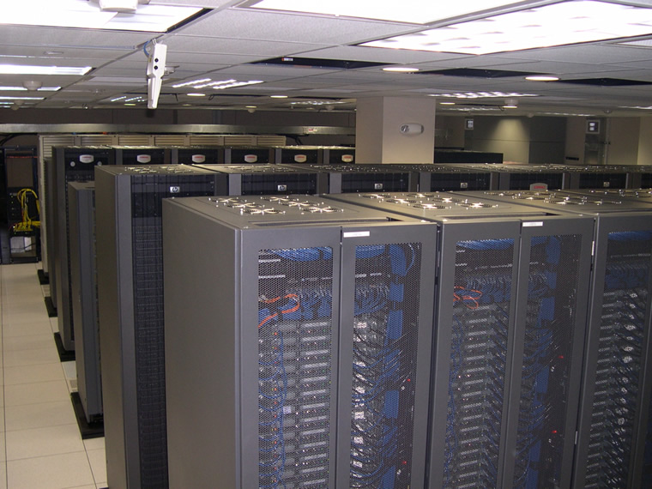A way that companies render animations, models, etc... Is by using a render farm of multiple machines all linked to render multiple scenes and models they need for their company or film. This is so they do not have to render each and every frame on one computer which could take years to complete one scene. In this case high tech machines dedicated to rendering are created for these companies that create the models, animation, etc... Because it could take more than 24 hours to render one frame for anything. This is why there is more than one machine rendering on one animation to cut the rendering time from using just one machine. So instead of taking more than around a year to render one scene in a render farm you can cut that down to whatever time you want depending on the amount of machines you have got rendering on the scene.