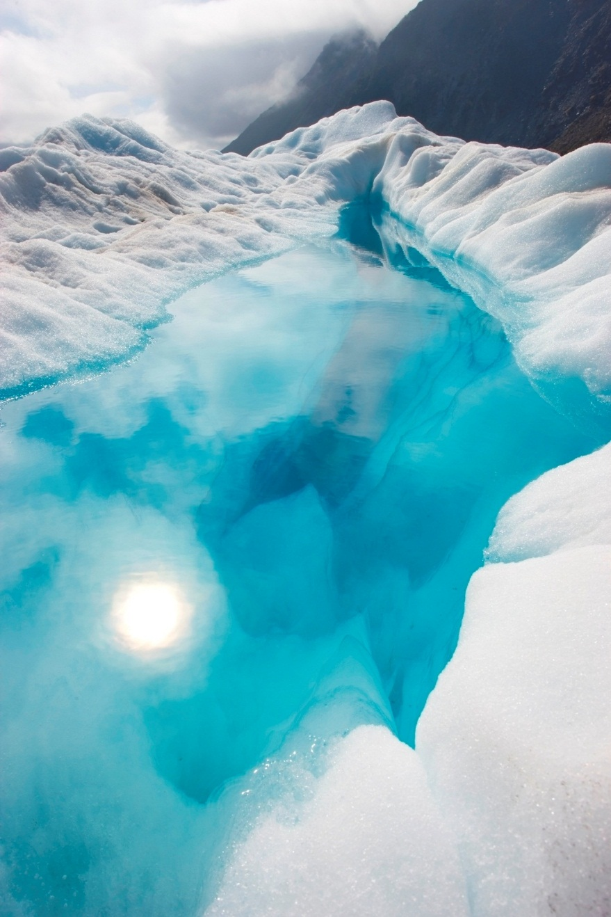

Mark Woods | Games Development | March 10, 2016

Unit 1

Assignment 2

Contents

Unit 1 – Pre-Produciton Assignment 2 1

Budget plan and resource list. 1

pre -production schedule 3

personnel and resources needed 4

health and safety, legal implications and risk to project 5

production log: including weekly status reports and change requests. 6

Concept art for 3D Assets 7

3D Assets 8

mood boards 9

thumb nails 10

location recces 11

production schedules 12

health and safety and risk assessment **Error! Bookmark not defined.**

contingency plans 14

Create concept art for a GUI design for your game. 15

Any other planning for racing game / game design 16

An evaluation of your pre-production process: 17

## 

## **Budget plan and resource list**

With a budget of 1 million pounds I researched the annual salaries of different job roles in the industry and put together a chart showing the different jobs necessary and the percentage of the budget each need for their work.

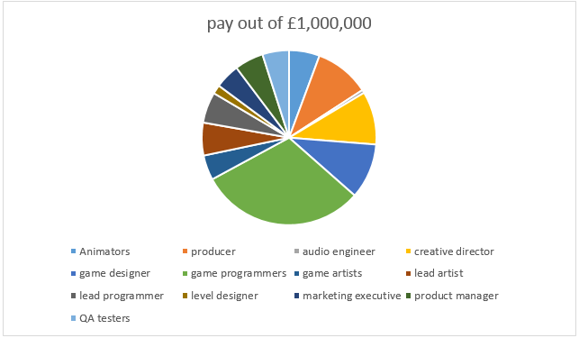

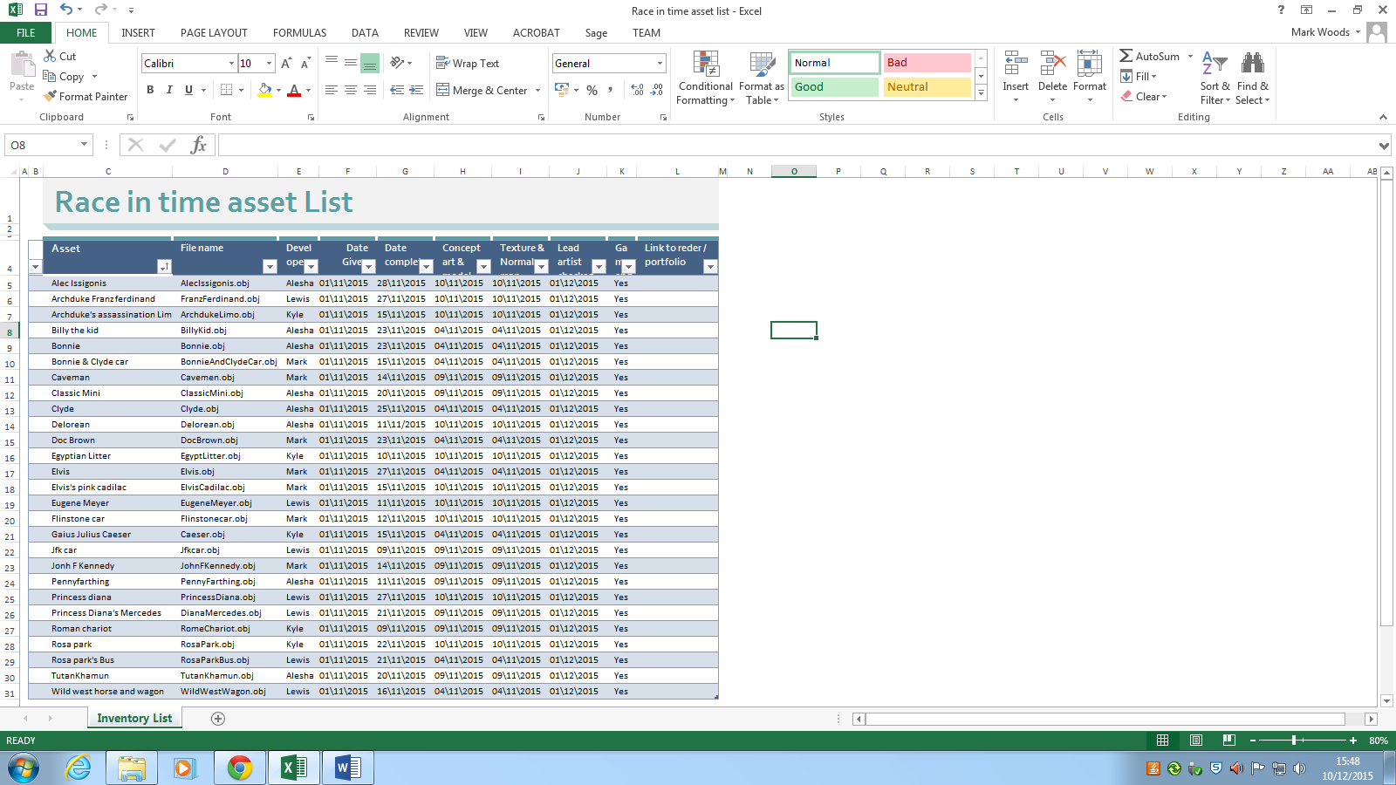The resource list includes all information necessary to plan the asset creation for the game including Asset description, file name, developer, date given, date complete, concept art, texture and normal map and game ready.

## 

## **pre -production schedule**

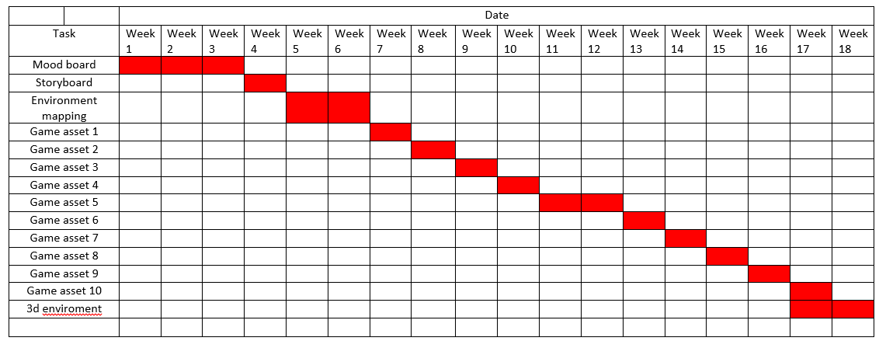The schedules for the assets in the game include mood board, storyboard and environment mapping and it helps to understand and lay out when each asset and task will be completed to help guide the production and keep everything to a deadline.

## 

## **Game schedule**

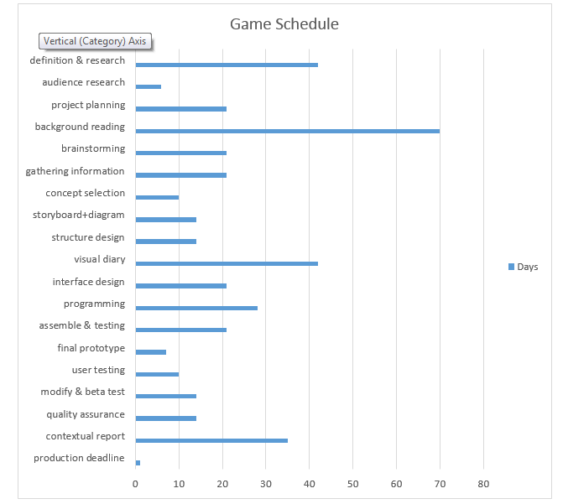The Game schedule is an entire overview of the game production from start to finish and it outlines how much time will be spent on each section of the design process.

## **personnel and resources needed**

Having the right personnel during a games development is crucial because not only does the development team include artists, programmers and directors but it would also need to include lawyers, producers and level designers. Every part of the production team is as important as each other and without one part of the team another part of the team may not be able to function properly. An example of this is if a team of artists didn’t have a head art director than a lot of the art they make may not have the right art style or be about the right thing.



If a game development project has all the right personnel then that is one step but they also need to have a place to work and communicate with each other well so that the development process stays on track and goes smoothly. The art designers and lead designer of the game would usually not have great ideas if they are stuck in a boring office room. An important part of the process for some teams of the development process is trips to places that the game might be based around, when on the trip they can learn everything about the place they are basing the game off and they can learn about the style of that place and time that the game will be based on so that the art and ideas in the game all have the same theme.

## **health and safety, legal implications and risk to project**

This table allows me and other employees to understand the risks to the project, this is important information to know because it helps to avoid things like file corruption, hardware problems and legal issues.

**-Morality in game plot and development**

It is important to consider the possible effects that the games plot and choices can have on the mental health of some players, the subjects that games can bring up can resemble real world situations and possibly influence players that they should act similar to their characters in the game. Violence towards figures in the game can correspond to violence towards figures in real life e.g. Police.

**-Age ratings**

The age rating of the game is very important because it keeps the messages that the game may convey away from people too young to understand or take in responsibly. PEGI is the age rating systems used throughout Europe to give video games a rating that fits the content within the game, The PEGI ratings are: 3, 7, 12, 16 and 18 but there are also other tags attached to games that show the specific possibly harmful content the game contains.

**-Copyright**

Copyright is important to consider when making games because it helps to protect peoples work from plagiarism, this also means that when you have ideas for your game it can be very close to other ideas and elements from other games which means doing research before is necessary. Copyright can apply to Intellectual property and certain game features.

**-Software Licensing**

Software licensing refers to the use of software legally whilst making a game. Programs like Photoshop have licenses and subscriptions that are necessary to pay for to use the software legally, some free software does not require any licenses but may have specific rules for content creators that use their program like having to share profits with the developer of the software or not being allowed to make publicly available content at all.

**WIX link for blog posts**

<http://markwoods10.wix.com/level-3-games>

## 

## **Concept art for 3D Assets** **3D Assets for racing game**

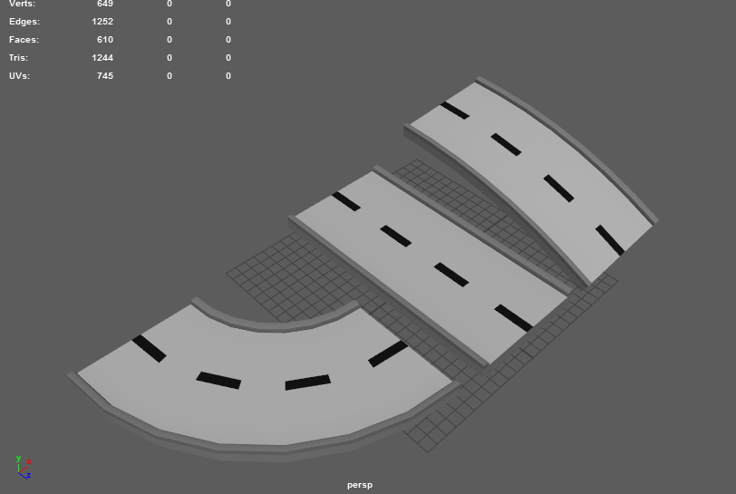

## 

## 

The concept art for the game consisted of roads and signs which I have various Ideas for. I used the concept art as direct references for the model creation which helped me to make them closer to what I initially wanted.

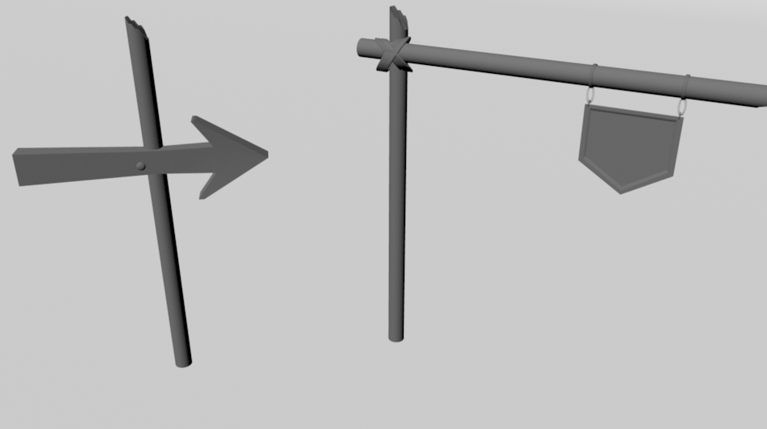

**mood boards**

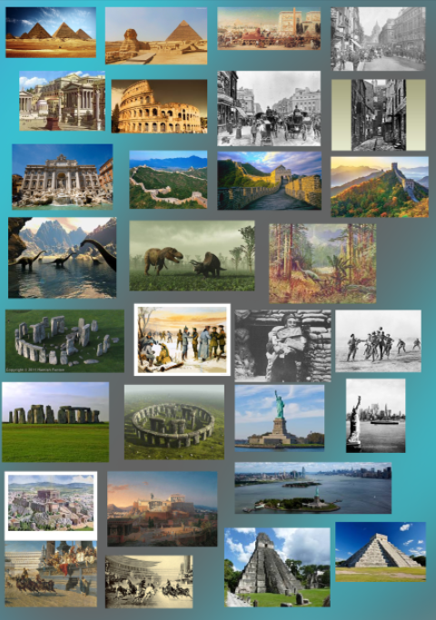The mood boards THAT I created helped me to keep the initial information and ideas THAT I had and generated more from the collected images. The first of these mood boards was generated for map design which was for the racing game idea called Race in time.

These mood boards were created for asset design which helped me to develop the assets for the final game, some of these images were directly used as references within Maya for asset creation.

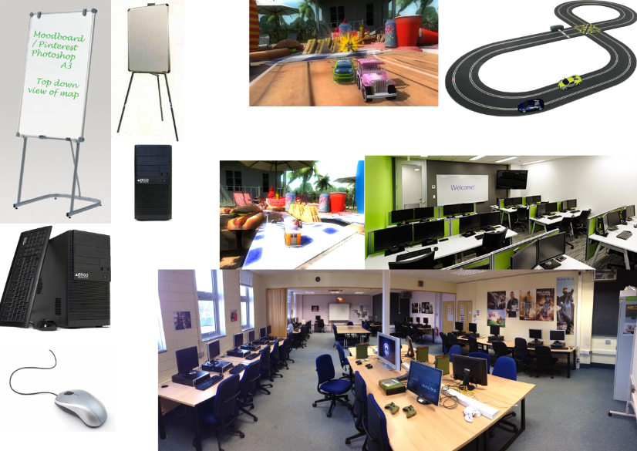

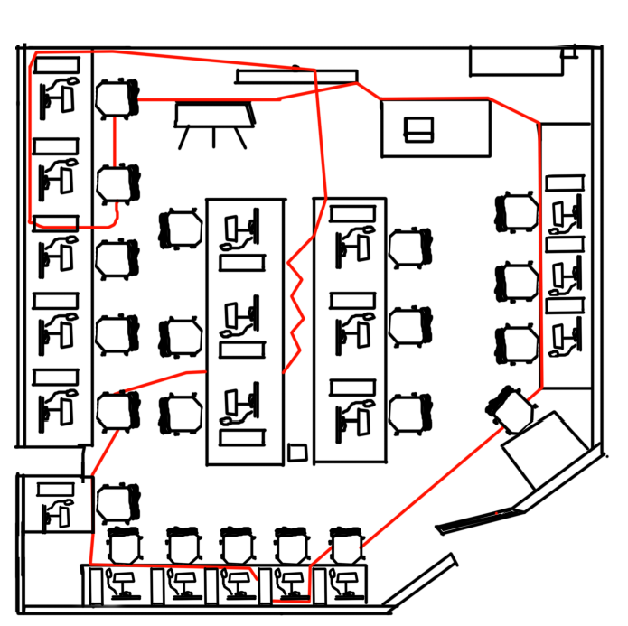

This top down image of the area that the map will be based in will help when creating the game. The red lines represent the track for the cars to follow but because it is just a reference the tracks position and route through the map can change.

**contingency plans**

## The contingency plan allowed me to plan for assets and tasks that may not be fnished in the time that I would like. It also helped other people to see where I was in my asset development process and where I wanted to be so that they can plan when they may need certain assets that I have created.

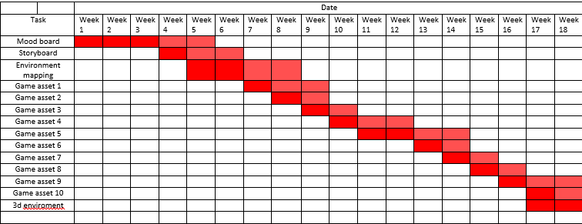

**concept art for a GUI design**

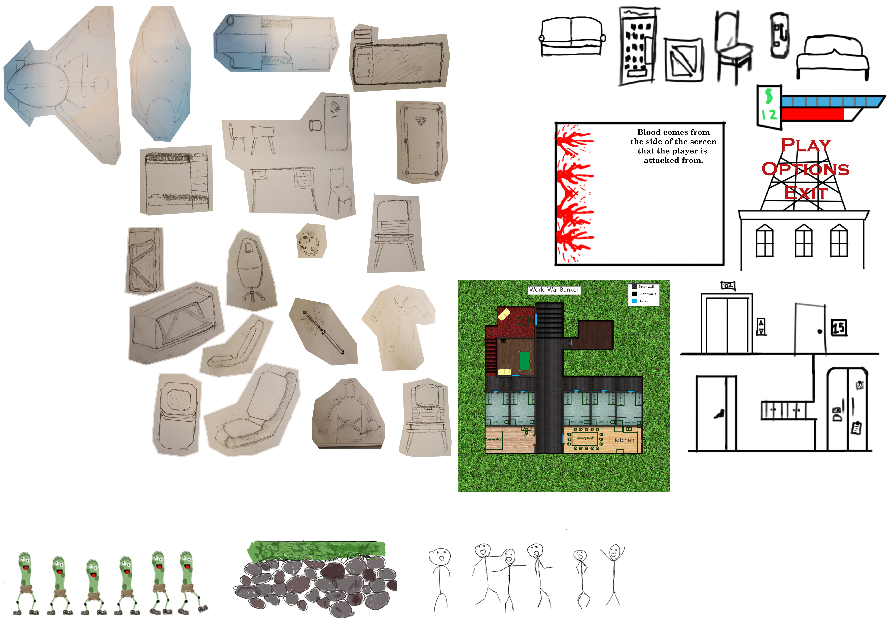

This Concept art for a GUI design is for a separate game from the racing game but it shows the main idea of the game including:

* Money
* Health
* Fuel/boost
* Play button
* Option button
* Exit button

## **Screenshots of folder layout and Google doc entries**

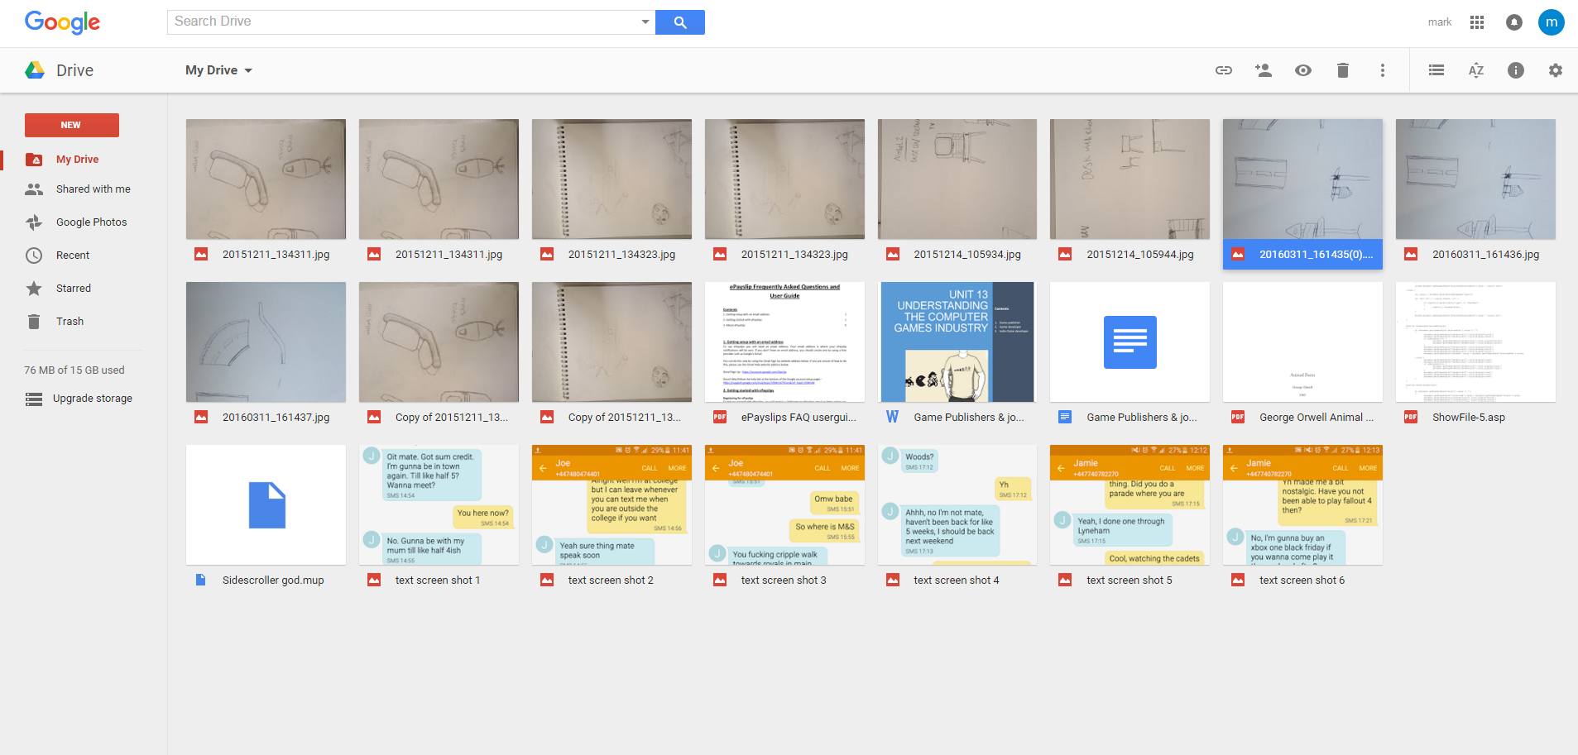These screenshots show the folders where the relevant files are stored and accessed, the layout of files and folders are important to projects especially if there are multiple staff members accessing the same files because they may get confused as to where certain files are or files may even be lost entirely.

**An evaluation of the pre-production process:**

**What Went Well?**

Overall I thought the pre-production process went well because I managed to plan a lot of the game design including assets and environments.

**What did not go well?**

Planning out the time management of the tasks was a difficult part because I did not know exactly what I would need to spend more or less time on.

**Use of contingency plans**

I am happy that I worked on the contingency plan because I used it often to keep an eye on the schedules for each task and asset but overall the deadlines were followed.

**What could be improved?**

Next time the planning could be improved by increasing the amount of schedule plans and possibly the folder structure and ease of access to keep the time spent finding and moving files and folders shorter.